Texas Healthcare Transformation and Quality
Improvement Program

REGIONAL HEALTHCARE PARTNERSHIP (RHP) 10
Annual Anchor Report: Appendices

December 15,2013

Region 10 RHP

Appendices: Table of Contents

Appendix A: Learning Collaborative Plan
Appendix B: JPS Health Network Behavioral Health Patient "Thank You Notes" Appendix C: May 8, 2013 Post Award Forum Regional Providers & Stakeholders Appendix D: June 24, 2014 Post Award Forum, Elected Officials and Steering Committee
Appendix E: August 8, 2013 RHP & Public webinar/ conference call regarding the process for 3-
year projects

Appendix A: Learning Collabor·ative Plan

Regional Healthcare Partnership (RHP) 10 Learning Collaborative Plan FINAL 9-28-13

Learning Collaborative plan authors and contact information: Aubrie G. Augustus & Gillian Franklin GFranklin@jpshealth.org
- Provide a narrative description of your learning collaborative, including membership structure, etc. Texas RHP 10 has identified two major common areas of focus across multiple providers to bring
together the hands-on clinical implementation teams so that they may learn from one other and
improve more rapidly. These two areas are regional priorities based on community needs:
  - Access to and Capacity for Behavioral Health Care, including Integration with Primary Care; and
  - Care Transitions and Patient Navigation.

These two Texas Region 10 Learning Collaboratives will focus on:
- Sharing knowledge, experience, and expertise in content areas and in improvement methods;
- Using data-driven analyses to drive performance improvement;
- Testing (using Plan-Do-Study-Act (PDSA) cycles) and implementing evidence-based changes in care; and
- Improving patient and provider experience .

RHP 10 is adopting an approach to hosting the collaboratives that promotes the following key objectives:
- Region 10 performing providers may determine their course of action mutually; and
- The collaboratives' work aligns with the providers' stated DSRIP project topics.

The results will be aggregated by the Anchor/host and presented to the Clinical & Quality Committee (see question #4 on leadership structure below). Because some providers may not be familiar with the evidence-based, nationally recognized change packages used for these types of collaboratives, the host will also be providing a recommended change package.

Each Texas Region 10 collaborative will run for 12 months beginning inDY 3 (CY 2014), with the option to refresh each year with a re-commitment of performing providers as well as more challenging, measurable goals and new topical content based on progress already attained.

- Describe the aim(s)/goals of the collaborative.

Collaborative goals and suggested aims are described separately below. Each performing provider will have the opportunity to tailor its aims, consistent with the RHP 10 approach for these learning collaboratives, as described in question #1 above . As such, each provider will select its own measurable aim to be achieved by the end of the 12-month period (December 2014). Providers will share their experiences in order to promote collective learning.

Expanding Behavioral Health Care Access and Integrating Primary and Behavioral Health Care Collaborative
The goal ofthe Expanding Behavioral Health Care Access and Integrating Primary and Behavioral Health Care collaborative is: Patients receive timely behavioral health care that is integrated with physical health care. The collaborative will focus on identifying best practices for better integration of behavioral health care services into the broader health care continuum by expanding and integrating primary care and behavioral health, sharing information, and collective learning to accelerate improved care and better outcomes.

True integration extends beyond the co-location of behavioral and physical health care. Integration will be executed with coordination, timely handoffs, and transparent communication between behavioral and physical health care providers. The intent of this collaborative is to improve care to be more
patient-focused. As such, providers must work together rather than in silos. This includes the sharing of ideas, best practices, resources, and data.

Expanding Behavioral Health Care Access and Integrating Primary and Behavioral Health Care collaborative suggested aims are as follows:
  - Sharing evidence-based ideas of an integration (or co-location) model based on care
improvement programs that are patient-centered, such as the Four Quadrant Model for Clinical Integration and the IMPACT Model to provide integrated care for mental and medical needs;
- Improved processes and workflows, as well as established principles of chronic illness care and collaborative care teams to ensure that professionals with complementary skills work in collaboration to care for a population of patients with mental disorders such as anxiety and depression;

- Adapt cross-screening practices, such as behavioral health screening in primary care settings, e.g., use of the Patient Health Questionnaire (PHQ-9, PHQ-2) and the depression subscale of the Hospital Anxiety and Depression Scale (HADS-D) to screen for depression (e.g., in diabetic patients). Based on the ideas of shared models and different approaches used in practice, screening for co-occurring disorders in primary care settings may be applicable in addressing behavioral health issues early, with the potential for improved health outcomes;
- Improved care coordination by integrated or co-located care team(s);
- Improved provider-patient communication while integrating patient-centered concepts into a standard of care, as measured through patient feedback tools and measures of shared decision­ making {SDM); and
- Improved patient self-management, as evidenced by increased numbers of patients with documented and achieved goals for behavioral and physical health.

Care Transitions and Patient Navigation Collaborative

The goal of the Care Transitions and Patient Navigation collaborative is: Patients receive effective hospital discharge and primary care follow-up, particularly for those at risk of adverse post-hospital outcomes. Many of the region's performing providers are undertaking DSRIP projects that will expand access to primary care, transform existing care approaches into a patient-centered medical home model of care, and implement care transitions or patient navigation programs that provide more proactive and tailored care to patients. While specific chronic disease populations vary across the region's DSRIP projects, providers are all focused on providing better care coordination across health care settings and ensuring improved chronic care management for specific disease populations.

Care Transitions and Patient Navigation collaborative suggested aims are as follows:
1. Selection and adoption of support efforts in care improvement models for improving care transitions and patient navigation of care, such as Project RED (Re-Engineered Discharge);
- Improved processes and workflows to make sure patients are receiving right care, right setting,
right time;
- Reliable and successful hospital-to-primary care transitions;
- Improved provider-to-provider communication, as measured through patient feedback tools and measures of shared decision-making;
- Improved self-management of illness(es) by patients and families;
- Testing and adoption of case management models for higher-risk patients;
- Reduced readmissions for target patient populations; and
- Improved outcomes for target patient populations.

- Describe the improvement methodology chosen (such as Institute for Healthcare Improvement (IHI) Model for Improvement; Plan, Do, Study, Act (PDSA); etc.), including key elements of design.

The learning collaborative methodology is primarily based on the widely adopted IHI Breakthrough Series, with some modifications to meet the learning collaborative requirements outlined for Texas' 1115 Waiver requirements. The key to this model is to combine subject matter experts in specific clinical areas with application experts who can help organizations select, test, and implement changes on the front lines of care.

The Breakthrough Series methodology alternates between gathering organizations to learn together and participants returning to their institutions to test and then implement effective changes in the clinical setting. Earlier convenings focus on theory, middle ones on reporting methods and initial results, and later ones allow collective reflection on lessons learned and planning for next steps. The ongoing direct access to others implementing similar changes facilitates dissemination of replicable practices and avoidance of others' mistakes. A key piece of the learning is access to experts and mentoring.

Based on IHI's Breakthrough Series and the Model for Improvement, the Region 10 learning collaboratives will bring together organizations testing similar innovations, clinical interventions, or process improvements so that the organizations can learn from each other and share best practices. In addition to data, participants will share successes and challenges, as well as identify best practices. As a result, all participants can benefit from the collective development of an effective and proven solution that can be widely replicated and more rapidly adopted as a result of the collaborative.

- Describe the structured leadership roles.

Each of the two collaboratives will include the following roles. Some individuals may serve the same role for both collaboratives.

Director
The collaborative director is the senior-most member of the collaborative management team . This person provides oversight and organizational support to the team executing the daily work of the collaborative. The collaborative director is the executive sponsor of the collaborative, reaching out to other senior executives in the host organization and in the participating provider organizations. The director is ultimately responsible for full participation and breakthrough achievements of the collaborative. The director monitors the program activities for the high level of commitment needed for success.

Project Manager
The collaborative project manager is responsible for making and managing the collaboratives' timelines for deliverables and activities. Key responsibilities include the recruitment of teams, the development ofthe collaborative participant manual, managing the reporting of measures and feedback processes, and organizing the in-person and remote learning events .

Coordinator
The collaborative coordinator develops program materials, sends email reminders, and otherwise makes each activity of the program happen. The role can include event planning and agenda coordination for learning events, sending reminders to teams about eporting deadlines and upcoming events, and day­ to-day conversations with the participating teams to answer their questions about different aspects of the program.

Improvement Advisor
The collaborative Improvement Advisor (lA) is the expert resource on the Model for Improvement, how to do measurement for improvement, and other technical aspects part of the IHI Breakthrough Series' program design. The lA leads the collaborative team in developing the measure set and the change package, recruiting the improvement teams and expert faculty, and setting up the data feedback mechanism for teams. During the collaborative itself, the lA often performs the following tasks:
teaching the Model for Improvement (which includes the PDSA cycle); interpreting measures results and creating the feedback reports; coaching teams that are struggling; and developing agendas and training plans for collaborative learning events.

Website Manager

The collaborative website manager develops and curates a clean, easy-to-use online home for collaborative program information and resources management. The collaborative website generally serves three functions: (1) a communication hub for teams to contact each other and the collaborative management team for support and resources; {2) a reporting hub for teams to submit monthly data and/or narrative reports of their work; and (3) a library of resources on the Model for Improvement and on the collaborative change package.

Analytic Support
The collaborative analyst supports the Improvement Advisor and the project manager with the regular data reporting and benchmarking analysis. If some of the collaborative measurement data is available through sources other than the manual submission of each collaborative team, the analyst is most likely the person to pull these data. In the development stage of the collaborative, the analyst may be involved in deciding how data reporting can best be accomplished.

Faculty (Subject Matter Experts)
The collaborative faculty is the group of local or national experts on the clinical and operational content of the change package. Faculty teach based on their area of expertise in the learning events (in-person, online, or teleconference) and are available as an ongoing resource, either directly to the teams or through the ongoing collaborative management team. The faculty role may range from one-time teacher-trainers to serving as a program resource from the beginning to the end of the collaborative. Often, how long each faculty member is attached to the collaborative depends on location (local experts often commit to the full duration) and on the level of expertise (the leading national expert on a certain topic is often too busy to participate in more than one or two learning events). For the Region 10 learning collaboratives, the Clinical & Quality Committee and the JPS-Ied collaborative management team will recommend and recruit experts with knowledge and improvement experience in the domains of care transitions and behavioral-physical health integration.

Clinical & Quality Committee
Texas Region 10 established a Clinical & Quality Committee to help DSRIP projects meet quality objective standards, link to patient-focused outcomes, and fully comply with Waiver quality requirements. This role included synthesizing and disseminating best practices. The Committee has reconvened starting in September 2013 to guide key decisions for the two learning collaboratives. The Committee has two subcommittees, each dedicated to the governance of one ofthe learning collaboratives. Participating provider organizations will not be required to join the Committee, but all will have the opportunity. The Committee will ensure that the collaboratives are aligned with the DSRIP project goals, including Category 3 outcomes, and promote provider achievement of measurable improvements in patient care and clinical operations. The Committee will monitor planning and execution of the learning collaboratives.

- Describe the measurement plan. This can include CQI processes and quality outcome data including Category 3 and Category 4 outcomes.

The learning collaboratives will collect, synthesize, and draw meaning from performance measures that measure progress toward a common goal. Using the Model for Improvement's focus on regular, frequent data collection,the collaboratives will use data that measure process effectiveness and the resulting care outcomes. Data will be analyzed using statistical process control methodologies, versus classic research statistics or public health statistics.

Performing providers will help set collaboratives' overall measureable goals in an iterative process. Each collaborative will agree on at least three measures, with the recommendation that at least one Category 3 outcome measure be incorporated.

For example, for the Access to and Capacity for Behavioral Health Care collaborative, such measures may include:
  - The percentage of the target population of patients screened with the PHQ-2/PHQ-9 in primary care
  - The percentage of patients screened with the PHQ-9 whose scores indicated a need to be evaluated for behavioral health needs
  - The percentage of patients with PHQ-9 scores indicating a need for behavioral health care who are seen by a behavioral health team member within 10 days of the PHQ-9 screening

For the Care Transitions and Patient Navigation collaborative, such measures may include:
  - 30-day All-Cause Readmission Rate
  - 30-day Avoidable Readmission Rate (multiple measure specifications exist)
  - HCAHPS scores on appropriate question(s)

Data will be reported on a monthly basis for two purposes : (1) to aggregate and benchmark, and (2) to show run charts of progress for an individual organization over time. The regularity of data collection, synthesis, and analysis will help draw out true performance improvement over potential natural fluctuations. Data may be reported through a project management website to enable reporting data and tracking progress toward aims.

- Describe the learning system design (how to share information and data, including Category 3 outcome data).

The learning system design is based on alternating periods of testing and sharing in order to accelerate performance improvement and collective learning.

The collaborative will include the following venues for convening and sharing information and data, including Category 3 outcome data:
  - A collaborative website to collect, synthesize, and share information;
  - A listserv to enable direct provider-to-provider communications (including Q&A);
  - At least two in-person learning sessions;
  - Monthly meetings (i.e., teleconferences, webinars, etc.for most months);
  - Monthly data reporting by provider organizations ,with expert feedback on progress; and
  - Regular host/Anchor email communications .

Additionally, each project team at each site is expected to convene at the intensity needed to manage their project work, share results, plan tests of change, and keep moving through the improvement and measurement process.

JPS as the Anchor/host will be providing a pre-work packet for all collaborative participants that will include lists of measures, the recommended change package of suggested best practices, pre-readings on the collaborative topic and the Model for Improvement, the program schedule, and the host collaborative management team and peer teams' contact information.

Suggested Timeline (subject to adjustments):
- October-December 2013: Pre-work period begins, with pre-work packet delivered to teams. Pre­ work allows performing provider teams to prepare for the learning collaborative. Pre-work includes a packet of materials, often accompanied by orientation conference calls and webinars. Pre-work guides the selection of each organization's improvement team, and directs logistical work such as scheduling protected time for collaborative events and regular internal improvement team meetings, development of a team's aim statement for the goals of their work, and collection of baseline data for collaborative measures. The pre-work period allows the teams to prepare for success, so that the collaborative as a whole will be a success.
- January/February 2014: Learning Session 1: face-to-face training on performance improvement and implementation of the care improvement model, as well as reporting on successes, barriers, and lessons learned to balance theory and practice.

- January-June 2014: Action Period: Apply changes, conduct PDSA cycles, and collect data to measure impact; each project team at each site should internally convene weekly to review what they are doing (project management, tests of change- PDSAs) and make sure they are on track as a project team; and the Anchor/collaborative management team will send regular emails to all sites.
- June/July 2014: Learning Session 2
- July-December 2014: Action Period
- December 2014: Wrap-up and report out

- Please add any additional information you would like to share about your plan, if applicable.

Recommended change packages for these collaboratives were developed based on best practices and input from faculty and the regional Clinical & Quality Committee. These change packages were provided to stakeholders/RHP 10 performing providers for review and feedback in September. As described in question #1 above, performing providers will have the opportunity to tailor the change package to their needs. These change packages are cross-walked to DSRIP projects. For purposes of space, the full change packages are available as part ofthis plan upon request. The change packages are part of the
pre-work collaborative packets.

Additionally, more information on the Clinical & Quality Committee charter is available upon request.

Appendix B:
JPS Health Network Behavioral Health Patient "Thank You Notes"

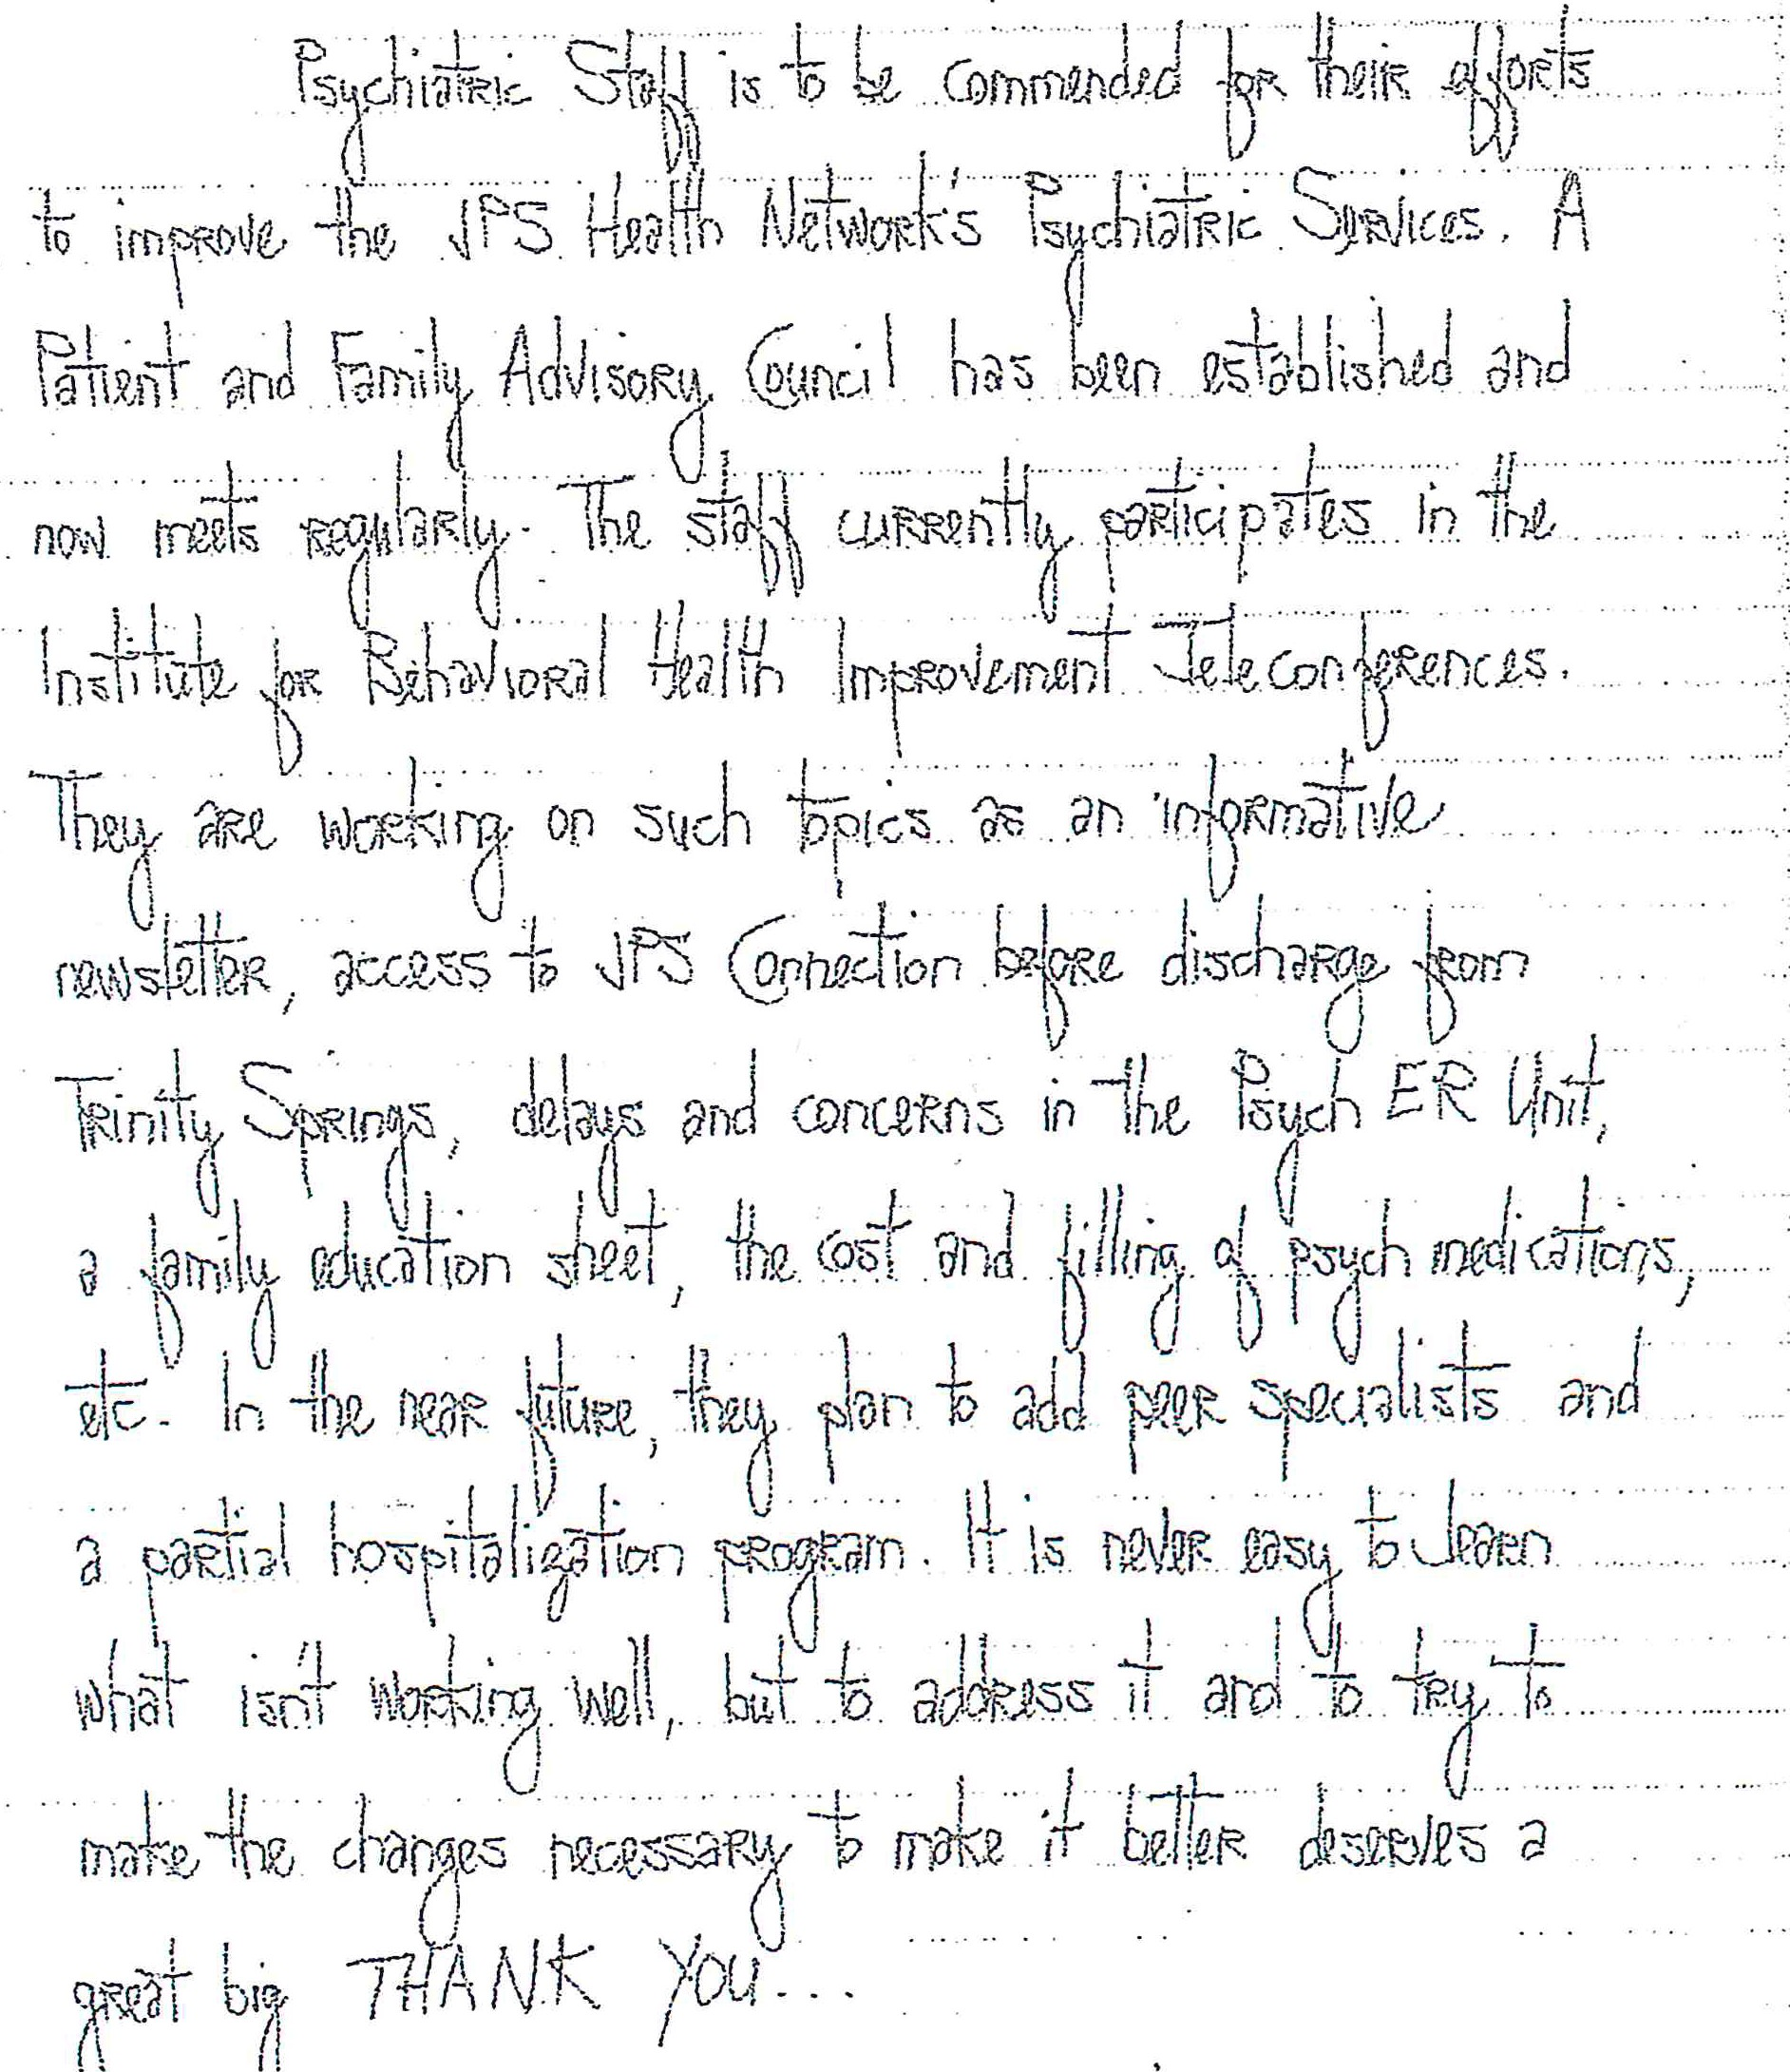As part of the DC Mgmt project we set up a patient and family advisory council just for behavioral health outside of the council for the main hospital. This consists of previous inpatients/ current outpatient recipients of care or family members of individuals who have experienced our services first hand. One of the family members from this group took time to write a letter to our staff about the great things being done and how wonderful it is.

'Tr ·;::,
IS
1nr:-·

This is a WOW card that another patient filled out to say how much she appreciated one of our Peer Support specialists interventions. This was hand delivered to us by one of our providers who was very proud of the peer support specialist's work. The peer support is also a product from DSRIP implementation through the DC Management project.

Wow!fRetcipieknt Name
£ -------

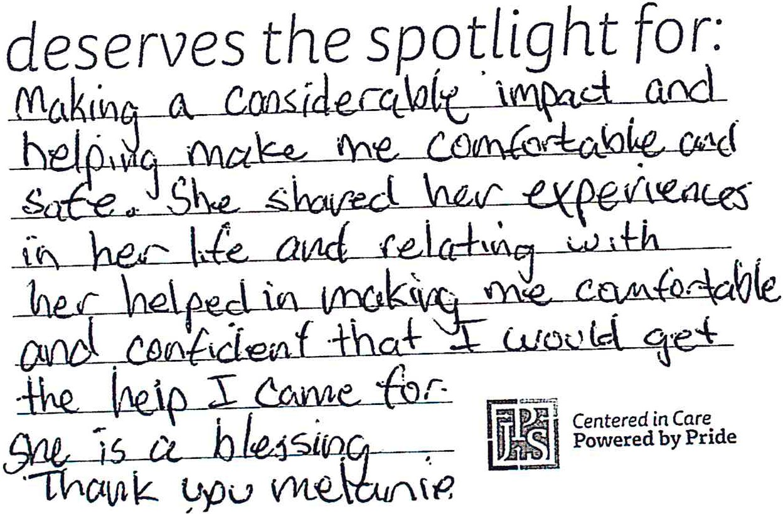

These are letters/ cards from patients and families who have appreciated the work done in the Partial Hospitalization Program. The last one is actually a letter from a patient's wife who expressed her utmost appreciation for the services in the PHP and how she is already seeing positive things at home for him .

.. . "· f v'-d ·-rs wc t.t

·./·

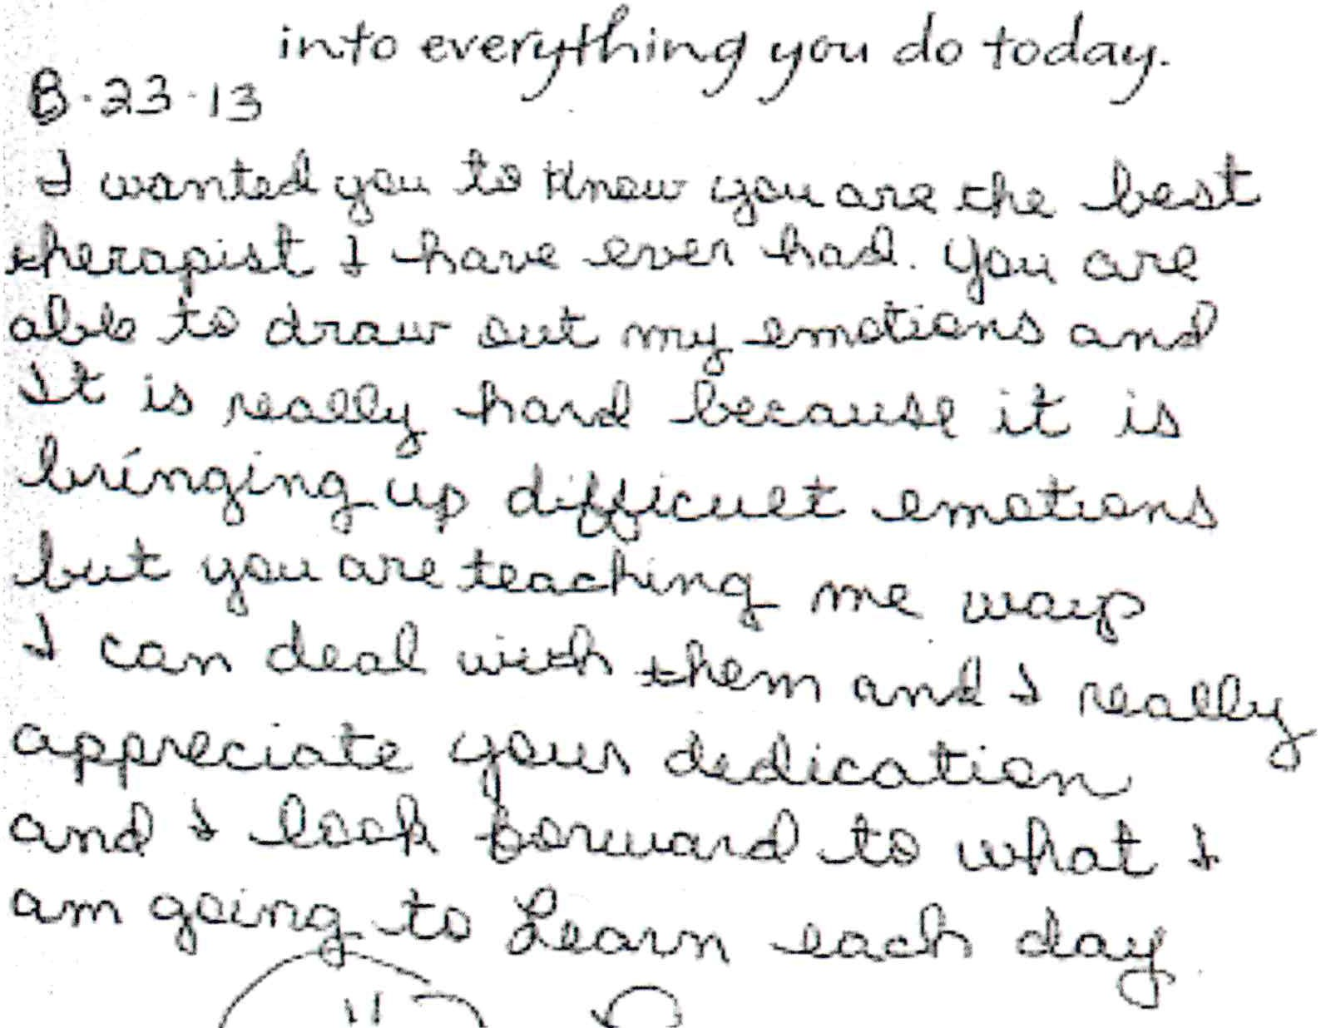

- L d
) i fohn Dv 11ft( AtnluA

,, FO WLMJ takts
! G
1
I '·<\dOI .)"'i''nf'A

OX!d.
'

.lJ"<).J

e . OLUnS e/)hwv\ble_ I "1 r D d1
w1i'h suv on. 1 1 OLVI" WDYi Vfu I
·JJJ«1 14 :q i Uvi l1 OJ\d tu;\, J·0-'
IL1 Yl and
; \tell \ope ['f)d lo\1{ ir1
' YY)t \

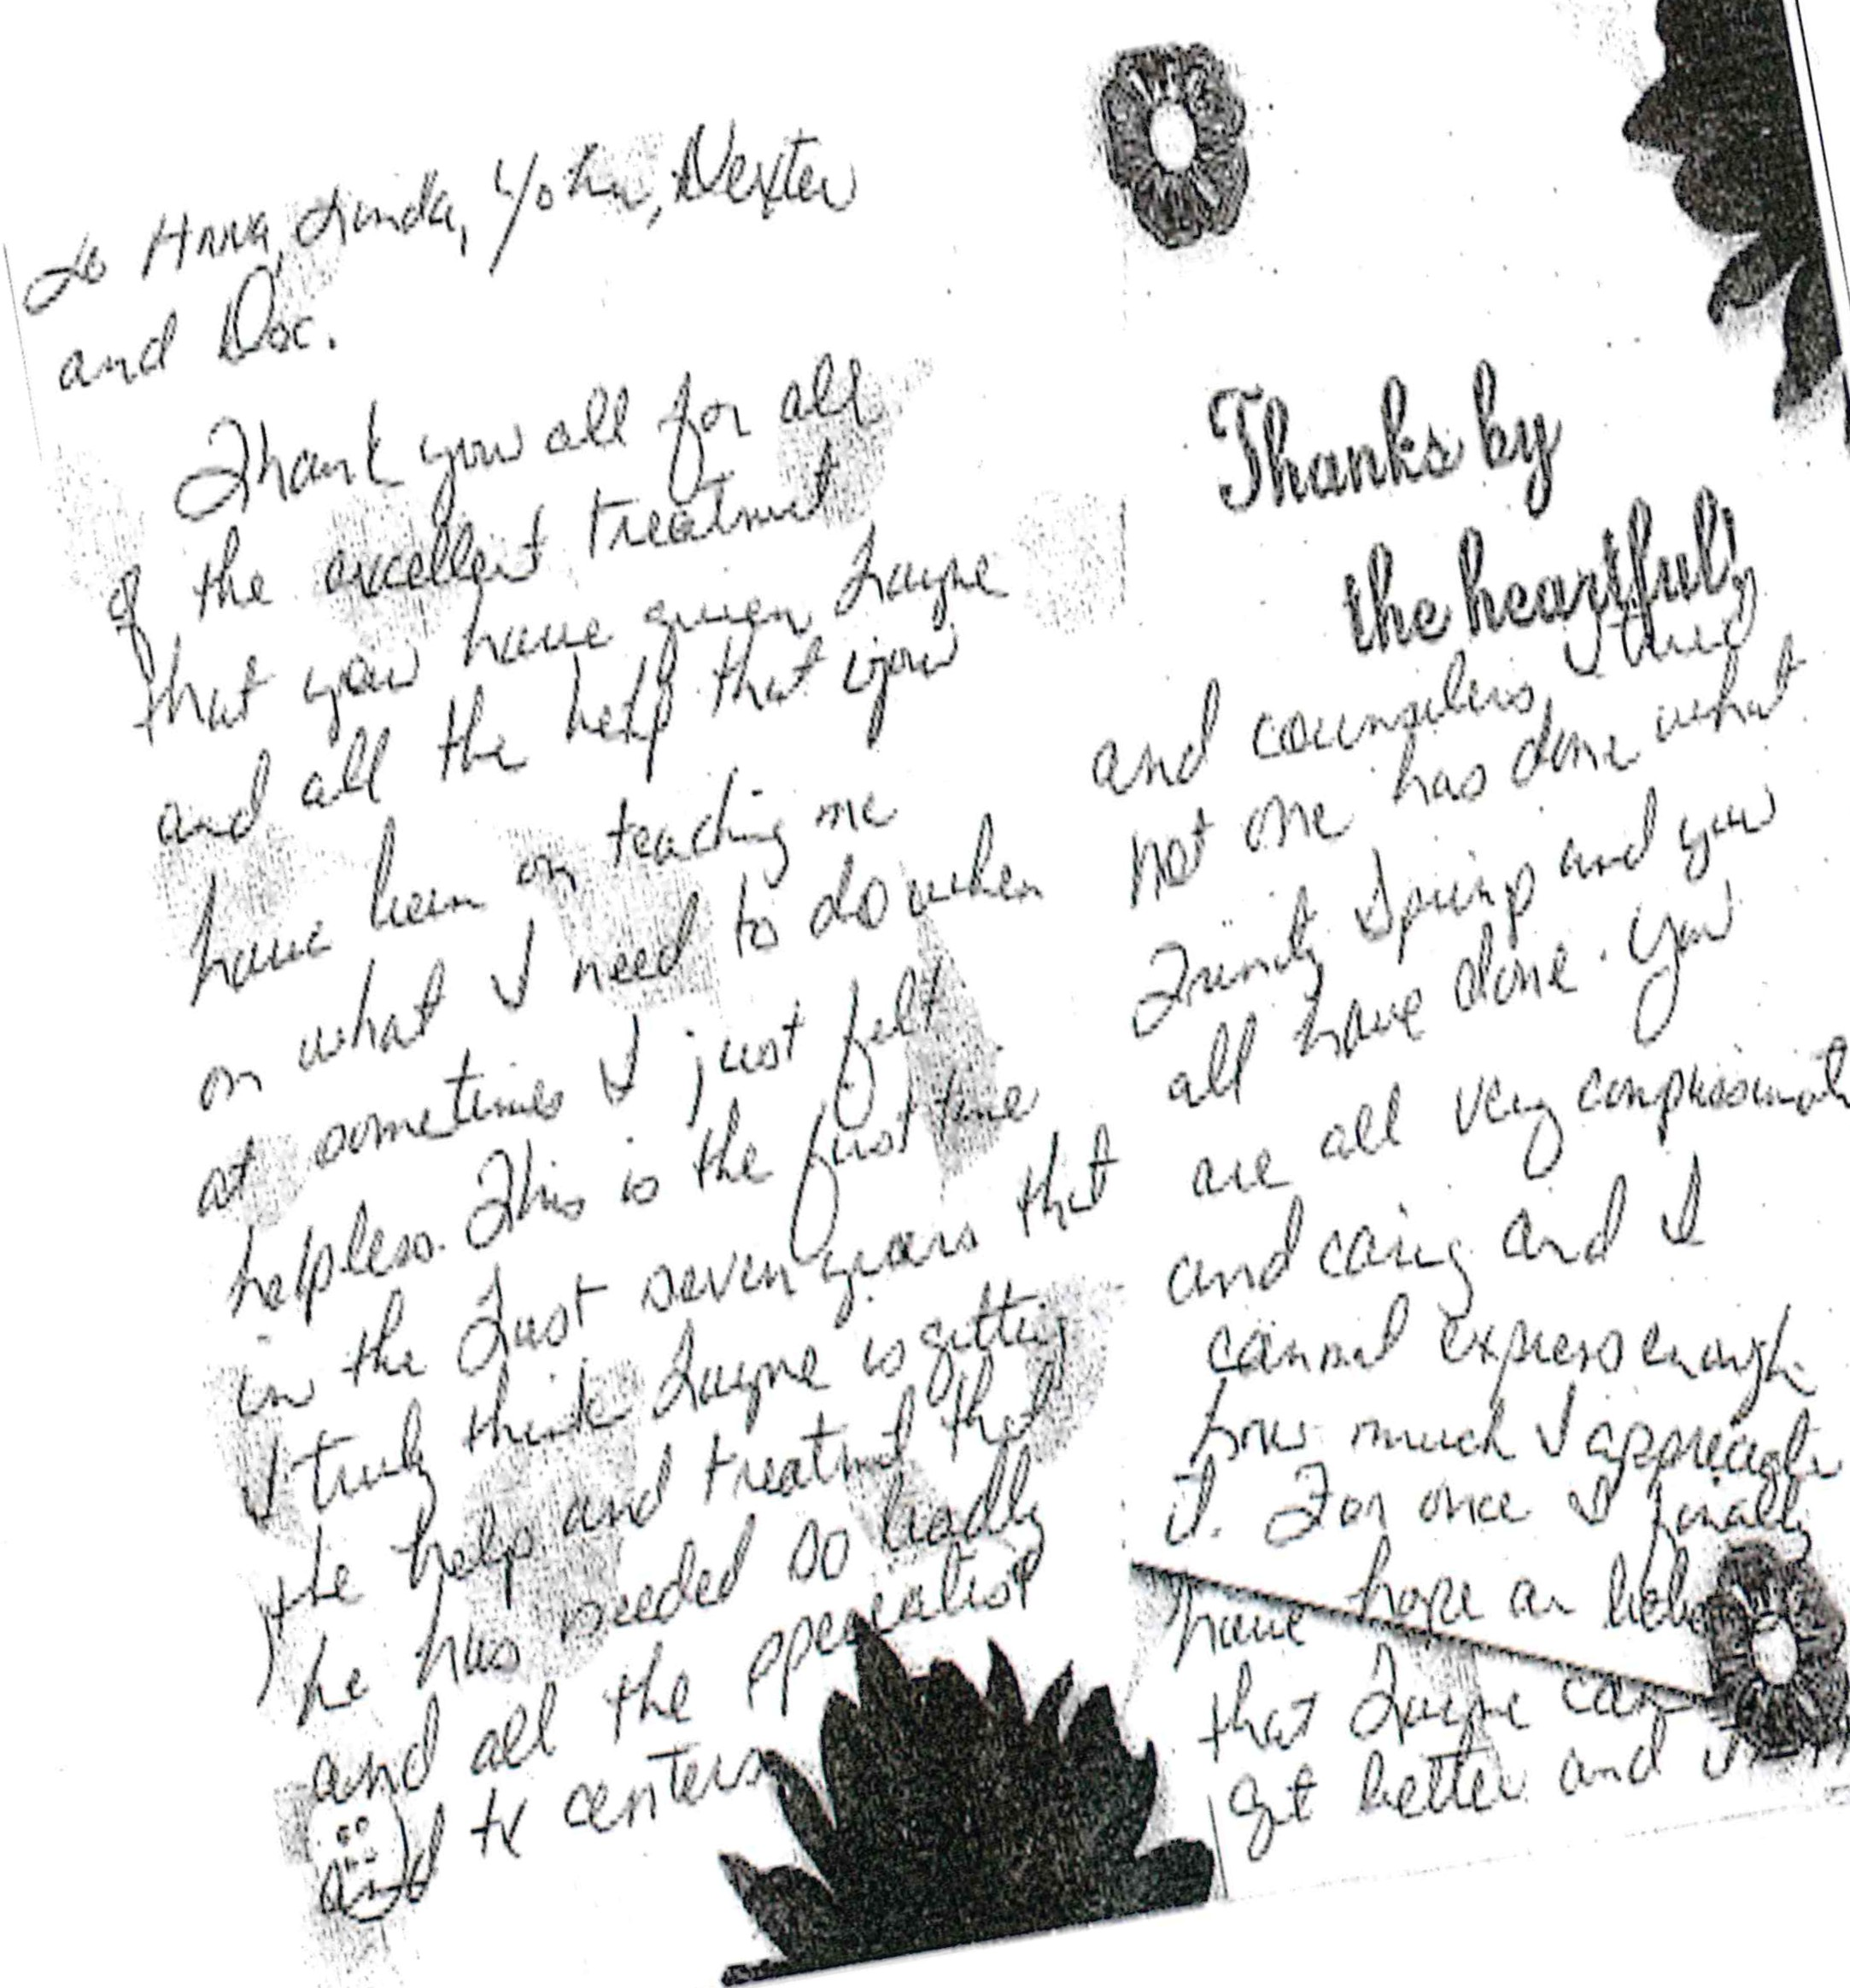

...-....-- ......-· -

Appendix C:
May 8, 2013 Post Award Forum Regional Pr·oviders & Stakeholders

RHP
10 IONAL MEETING
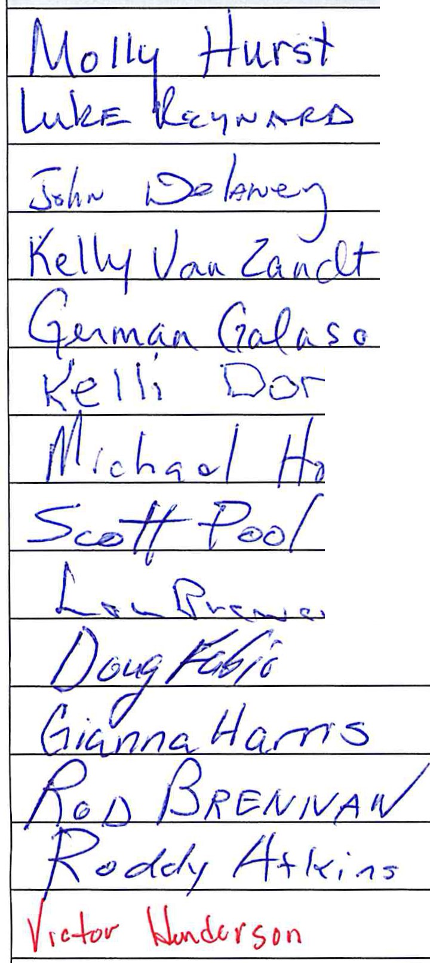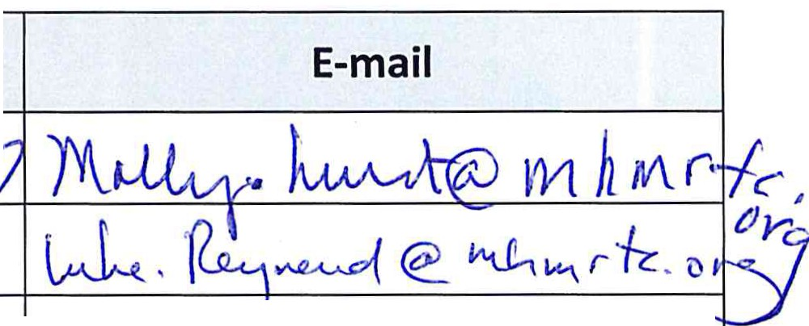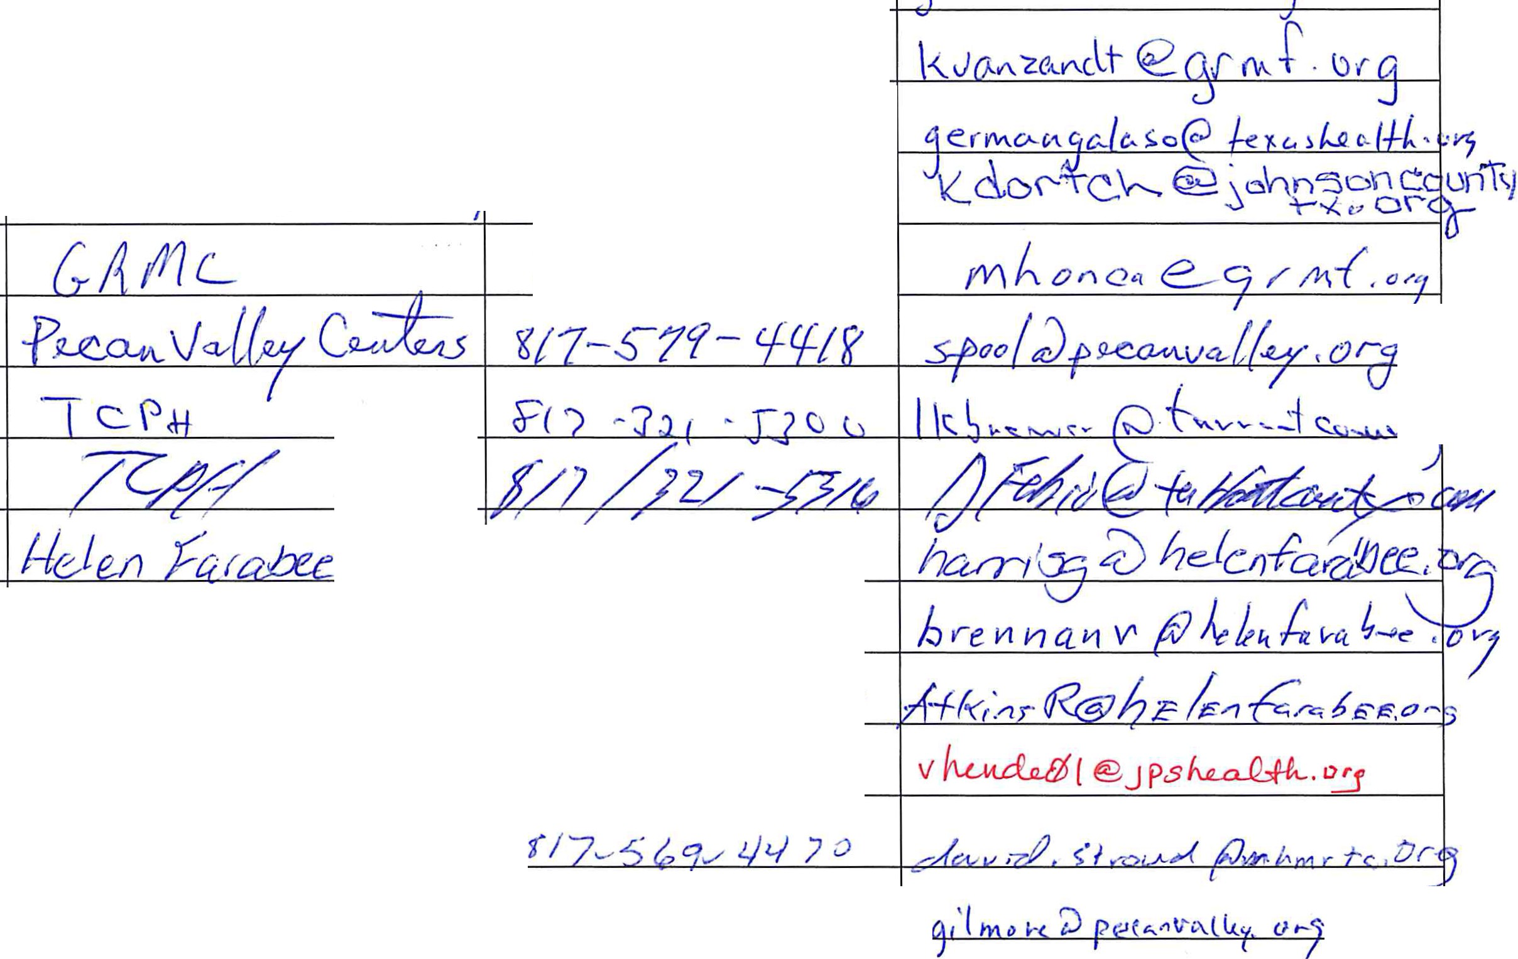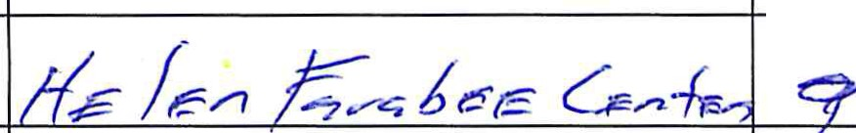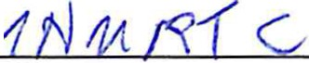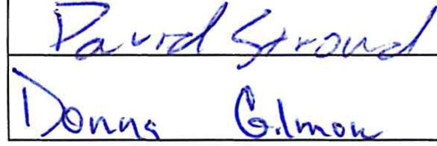MayB, 2013

Name (Print) Entity Phone

fv\ t+ M tZ 'letrfO.M 4o <6 L 1'"' 5 G 9- !:J(,h ·
M t;; I \ \ - <-; q-s-{Q ·
LP) R:eAI PA,H 4L I 9?'J.- - l:l<J-4/'5'0 MIIS' I ,crLd ©.,{n.AJlW>rC.. O !'\'

G f--1/'A_ I a LJ- - l4 q to
lt+fL L-2...')<.. - G. o..r
·oor-,·r- ,.._-
0onh O\; Count crl · .-d.(oC6- Q;;zqe>

f\ e. J_)L-( ?/]) /{})_

I ., 'S}; \.......... '--.\ v-S J>- ' R '= I I - · <!! I ' I .J .J._ ( J -f \,) I I 1, r'S !::..o"v {•'-' ' -- · --· 's.J..,..J'-J 1,... '-l'-

iei l q-fo fYjl r 5 365

II ·-c. '(
7'-to ?. 71·- 3/ )._ 7

"'7'd .fl/7- '3 /0(

)\?5 \r-\ 11 qz_7 -s 17

/P
?.J..,f. ftH_, 11- ':51'i- 'I'll rJ

RHP
10 IONAL MEETING
MayB, 2013

Name {Print)
Entity Phone E-mail

tod - d-e>b - (oct '5(

>

//_, {c .f-
<{) l/- )02 .-;;J_ 7 I
g('1-1ut--ll{go

0 ((f'. v fA n
f+-04-
·rfl;z -- / fq Vi . I f/1- S)j r z_ 7 0 (
Jt}(t;-_5 4J&Ai 4-{ I 71:Z 3g9; - 1

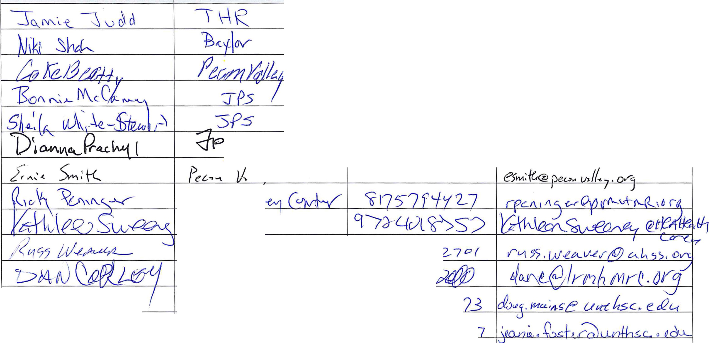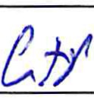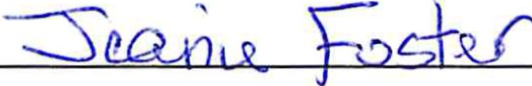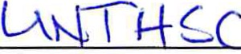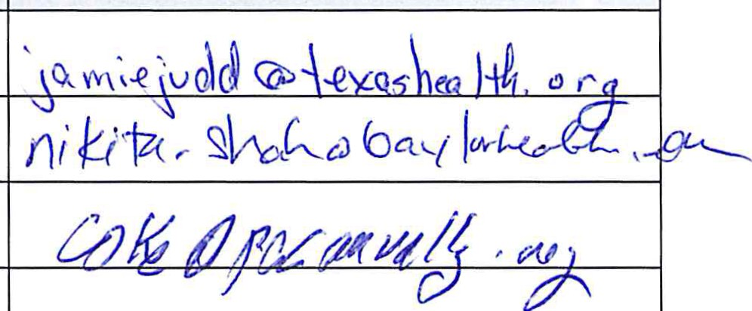b0(){7 jJ\}d us £A

HSC J7-'73s- vv

f3 17- 735 -OJ(

RHP

10 IONAL MEETING
May 8, 2013

Name (Print) Entity Phone E-mail
c0-'( () \.. • V\c...-\" «.. ""'"""-.,_v ·\-c._ - e-V

(!r... .;n l (a. :\::...' ../\...AD '-'\n\

. . .
5.?' \1- s-L..C\- 4 43o

ictiMJ (U' \A {s;" Jl0S P6- ,C(II) - 70_:). --- 37 I fwaJ (/ _jp S /u o.l_ l , cv-(l
- . .)

\\kid \lack ei kirex\s.DQ._ l{ q s d I , 4-(o - / lf ),
hsc t \u_,c)c hc ld rei\'2:> ..C.c

fYJ

PeW./ / A L' V\ w ((_ 1-1 s Lto-- 6Z- - 3o6"3 fct

.s. f1'1\@ i..J i Q...f-t.'11·$) 'lJ.cvvv
m

LiAc'-1 h-a (
D I i-:?
e-re

lA\f2- l+
()"() c! edO iv '1-q (/rw,/J1/5:J/C/JI<?I

0l0S--'L(:}b-
p

009 I 01.
J
:::hil r 6)G 0\ -e. v€tt?\{t l
?'()I -1--r

Ct7'fVI

J 1 IL-
(J /9-- ,J f /'7 S' 7
i-(7'-/0 r/1( Cl tv (j) C'(.l I ;;
'-J
p u5

g{:;VI.

;ti
( ;L< ,( -iJr j;.,-r ..J c,·i- y t3 f'/ ·- f r -o otfJ 1o""" .J.'f'rJ"'-.k..A"-' rv. r·tt,o'J

'E.-Lci/II8V+£ Joull \£
fl thrv crf IM<..IZ.hN 1G\lu,J'T\ 'B \1- 564- Lf 1'<1Li e\ ew(:' v ·, .V\devtvvC @ hyYYY\-c ' U)g
'

/l Y1 c(L-J Ha r-1- ,r._,
;r/t C0 For - .. . ftlt?. 7 9 7. :55-:>::r r-fr .q_ -;;;Jt t<-- /C! L . I"()

( I
L -8.\5 GoO\<( Cl\t LD\\·Et-\ ' C'62.- s- -ll\ 3o \ C\ .\-).,,\o e Go"b\c - \J 1- <. 1 0·_.
C'

j'ACJ\(
VJ i L-D tc
[tJ,Vl) f-£ lotlft L L/{.,C( -lr;-<c "z ,t:;J cfte..K- LJ t l.-(;))<€? Ll tll.lk.-f

/j([VI..., t!l-c-fl.tf ""' '1 -P7 , 'c/,,- ( 2-7 '-( 1../ '?r- )o9-' · f.- ! /1 :&c c;/ L //'-- '-/-e·f--
/

('' ,h,v-: l "'ct.. .
P.s
"-t - y -z_- "1-3'-t g Ll :,P l-\:h.o ..--
'--" '-._.)
I

L& 5 C...L--"1 f.......... ""\\.4 )1 5 r\[ /o'L- 'l..'1- \ 5 s ""- l ''- 0 y... f l--\ G--1\--t---
b -c j7S 76L-3ld--s- \::, """'o r ke.«_ ( te. ·"'
--

..\

- -'L;\AJ \u2-r- f s
._.,. ,J
_
- -_!11- 7b_J.----=- :3> - - vJ"' (!) Jf't1v(' ( , aG

RHP

10 IONAL MEETING
May8, 2013

-
Name (Print) |  | Entity | Phone | E-mail
1-b frrt / xus  v | .kJ | p ;Jg,Jh J.i) rt- (C · | X/2- l | @4.-q Mr JCJ .· o1 4. IfL /uv
W-c-rdv 13vr-l<ho!det- |  | VPS | X 3 8-&"0 | u /0  whtu-khtJI @ ';ps hea.l h ·t;r9
j,J 0'- ) ........... vr:;.,.J |  | J?_.S | 3\..J 1
L \.J  13¥Lo e-ka--"' |  | tu- &-:rst t!Ti- s. | '2--llf-- qtf7--lf-V{§ | - t - c:e;.
 |  | Nfflf./2.>t-0 | tflt 7.... s CJ- 1/--1-fs; d....
c5o AJ 1 1\J::s |  | 4J..r#.ll!...r-e.- | '
u

s+ ; hr:;Jt-fv-z h rn ..

Today's Agenda

REGION 10
REVIEW OF CMS "INITIAL APPROVAL " OF
RHP PLAN AND FOLLOW-UP REQUIREMENTS

May 8, 2013

RHP Plan submitted to CMS
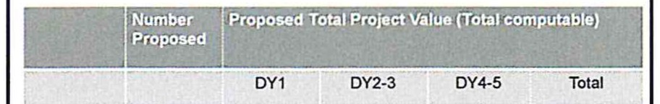
Initial plan nla $48,707,230 $48,707,230
submission

  - Welcome/Meeting Coordination
  - Overview of CMS "Initial A pproval" Letter
  - Four-Phase Revision Process to get to "Full Approval"
  - Question and Answer
  - Regional Engagement , Timeline and Next Steps
  - Public Engagement Requirements
- Learning Collaboratives
- Payment Update
  - DSRIP DY 1 Payment and Recoupment
  - DSRIP Payment Cycle - DY 2 to DY 5
  - 2012 Final Payment
  - 20 13 Proxy Payments
  - Region 10 Website Development

CMS Overview- Feedback Related to DSRIP
Projects

  - No.1 - Initially approved projects (Table 3)
  - No.2- Initially approved projects with priority technical
corrections (Table 4)
. No.3- Projects initially approved, with an adjustment to project

Category 1 | 111 | $403,154,831 | $411,909,038 | $815,063,869 | value (Table 5)
& 2 (Projern)  Category 3  (Outcomes) | 220 | $45 ,538,999 | $116.651,376 | $162,190,375 | - No.4- Projects not approved at this time (Table 6)  - No.5- Category 3 projects not approved at this time (Table 7)
Category4  (Providers) | 18 | $21,985,585 | S34,402,375 | $56,387 ,959
Total | 349 | $470,679,415 | $562,962,789 | $1 ,082,349,434

CMS Overview -Additional Feedback Related
to DSRIP Projects
By the Numbers CMS initially approved 84% of the projects & 79% of the DY1-3 $$'s requested

- No.6- Category 4 Domains
  - No.7- Replacement Projects
Initial plan | n/a | DY 1  548,707.230 | DY2·3 |  | Total  $48,707,230
submission |  | 100% |  |  | 100%
Category 1 | 99 |  | $306,010,154 | Not | $306,010,154
&2(Proje<:ls) | 90% |  | 76% | approved | 38%
Category 3 | 174 |  | 535,303,437 | Not | $3$,303.437
(Outcomes} | 79%, |  | 78% | approved | 22%
Category 4 | 16 |  | S21,9ss:sss | Not | $21,985,585
(Provkiers) | 100% |  | 100% | approved | 39%
Total | 292 | $48,707,230 | $363,299,176 | Approval | $412,006,406
 | 84% | 100% | 77%  79% (DY1·3) | deferred  to9/1/13 | 38%

- No.8- DY 4 and 5 values deferred
  - No.9- Learning Collaborative Plans
· No.10- Post Awa rd Forums

Timeline
- U-/fiiJIIIl·AIII .PIIIw.a.dll  - Pa W ..  - t.i./D..t.m...·.T_tlhlb!FIIdlld  ·..-....  • 0..4./.B..I.J.i.a"l·"*W l.alf | May2013 Jlly2013 Stpt2013 Nov2013 Jan2014 Mard\2014
 | -ProjiG·VU-\nbf'"OoiS'"""'I
1010l/201J ·MIOEJIJbliUI TJf1«1
bC.fiOIY]

10/01/XIJl · lUI'I'IrtCollbcntiftfllln
IOCMS
 | IB/J1/lt114·Cittpy]lmpvftmtrf:TI I5rt.bf'Pn:Mdrn t:atn/1014·AIPrDftttsi!KtMF .rbyCMS
-= -rr.

Important Dates

•CR/U/2CU ·...........,.....

  - fi!/U/JIIl ·fiGC,..._.,._ ..CMS

May 2:9, 2013
:.
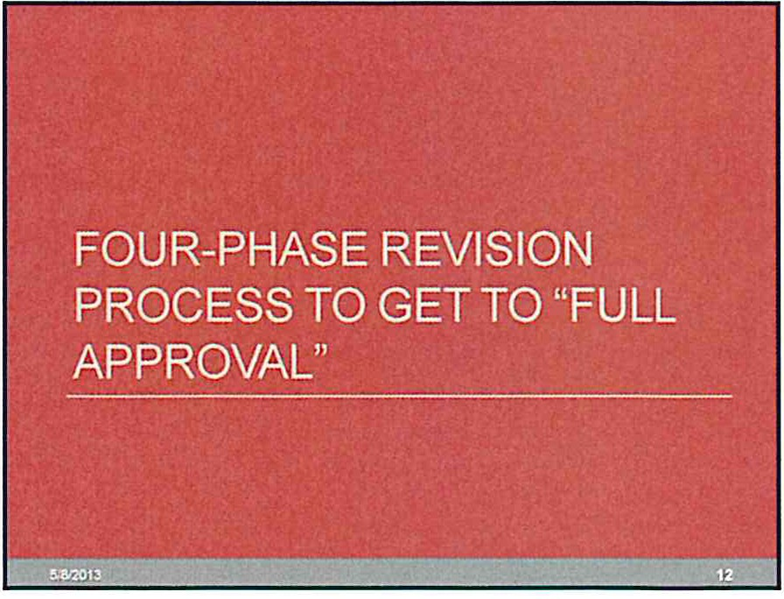Arltic pated date by which" an RHPs wiD have received CMS Initial
Review Findings i

May· Sept. 2013 Phases 1-4 RHP Plan revisions take place
July 31,2013 Replacement projects due to HHSC
September 1, 2013 CMS Completes first valuation review for DY4-5lncentives October t .2013 -Priority technical corrections submined to HHSC
CMS and HHSC complete standard target setting methodology for
Category 3 outco mes
    - RHPs submit learning collaborative plans
March 31, 2014 Deadline for full project approval
Technical corrections
Modifications to projects or valuations
    - Category 3 improvement targets for DY4-5

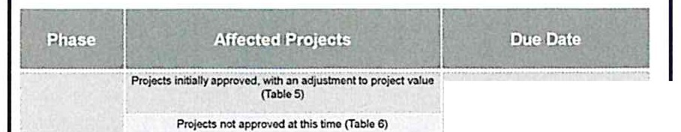Resubmission to CMS
- Take place in four phases (Phases 1-4) belween now and October
1. 2013
- HHSC will provide detailed cover sheets for each project requiring
revisions in Phase 1
  - A summary of changes made will be documented on the cover sheet and
submitted with project revisions
- The cover sheets will be sent to the anchor and distributed to providers
- A copy of projects and outcomes requiring revision will be sent to providers within the next week
- Submissions can occur on a project by project basis but must be funneled
through t he anchor
- Projects only formally appear in one table in the CMS Initial Review Findings. but that does not mean the project does not have other issues

1 lt,;provomontmih:Stonesowrbp tt.JrgOU
(profods priorif1toc hnblCOflcetiorl idontif"IOdlnbblo4)

All projocn - eotlfirm.reviso.ldentifyqv;lll!ifi3blep: !iont
2 imp3ct; ndModie.;llclllncligtmtlmIOfe3chPfojed

Projects Ylittl DY2 s idontl1i.dby HHSCn M<lding
3
ramJoninordoftonW:e
OY2p;rymont

All Pfojocts -ptiorit)ol«hnleal ti)(IC!Ction$ ; ndCO!. OQOCY 3
4
eh3
Phases 1 -4

w;Jh;1vo 2tlcbyslromlhad.tto ' projocl ccwt shoots ;vor rto tovisaprojoct infonn lion ro-submll Phaso 1 tGHHSC

ProvldorKtivltios btodto!M.
PJoen$ wm
bke pbeeovorthocours.ofJuneilnd
"""
Octobcr 1.2013

Phases 1 Options:
Approach to feedback for projects initially approved with
an adjustment to value (Table 5)

- SA: HHSC Comment - Flagged by the state and confirmed by CMS
- 58: CMS Comment- Project value was an outlier compared to
similar projects based on information available to CMS
- 5C: CMS Comment- Patient satisfaction outcome does not support project value
- 5D: CMS Comment- Other Comment
Phases 1 Options:
Approach to feedback for projects not initially approved
(Table 6)

- 6A: CMS Comment- It is unclear how this project addresses a community health need and/ or an area of high need for the Medicaid and uninsured population . This project is not approvable unless the provider can make a compelling justification.
- 68: CMS Comment- Specialty care project without a clear benefit focusing on the Medicaid/ indigent populations
- 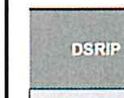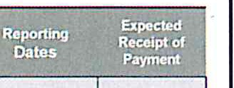6D: CMS Comment: Need more information about this project to initially approve

Estimated DSRIP Payment Calendar

OY1 (9f.30/ 12) HHSC Plan Approval - Subn"Vssion to 3111113 4130113 CMS ·Refunded Amounts ?

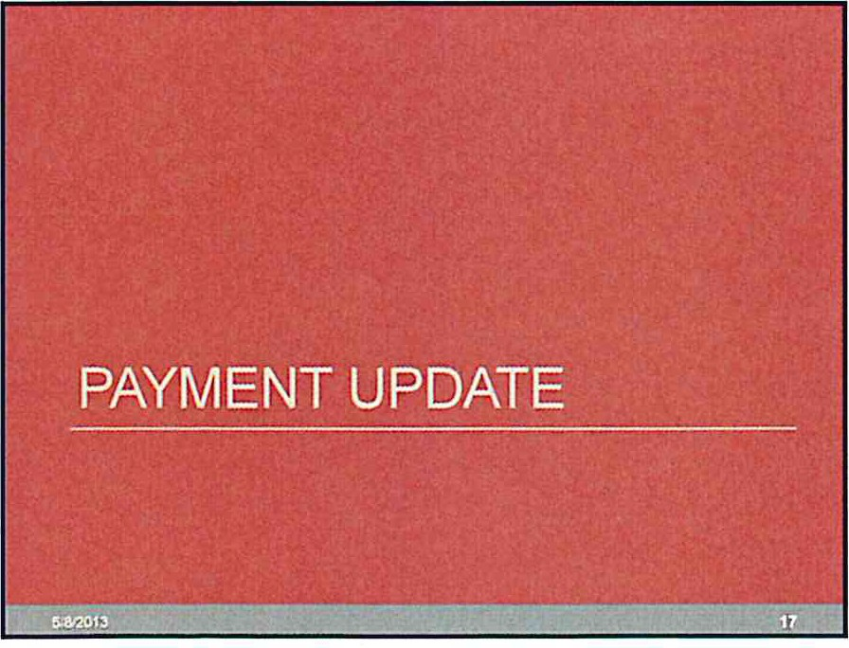OY2

1 P.!destone Reporting through J-31-13 est Aug\ISI 20 13

eslOctober
201 3

Milestone Reporting through 9-30-13 est October 2013 est February 14
&Category 4ability to report

OYJ..S

Mdestooe Reporting through 3-31 and :mnuat Category 4 Reporting

<J3() est. June

OY4·5
M estone Reporting through 9130 10/31 est Janual)'

Category 3 outcome metrics 4130 est June
reporting through 3-31

Category 3 outcome metrics 10/31 est January
reporting through9-J..

Who will qualify for a DY2 UC advance or
"Proxy" payments?

1 . The provider must have a source of public funding for the non-federal share of the advance payment.

- Public Engagement
  - Performing Prov iders

Other Items for Discussion

2. Se; o h r 1 gu?citi n9 f ;e" Y h e edwith
affiliation agreement and the signed certifications for the provider and
the government entity.
- The provider must be listed in its Regional Heatthcare Partnership's
(RHP) plan as a participant in the RHP.
- . The provider must have been actively enrolled as a Medicaid provider
in the Stale of Texas at the beginning of DY2 (October 1, 2012) .
- The provider must have submitted , and be eligible to receive payment for, a Medicaid inpatient or outpatient claim for payment during DY2.
- The provider must have either submitted an acceptable UC application (UC too l) for DY1 or have been eligible to receive a transition payment for DY1, regardless if a UC payment was received or not rece1ved for DY1.

m

  - Elected Officials and RHP Steering Committee
- Region 10 Communit y Forum(s)
- Learning Collaborative
  - Mov ing from Concept to a Formalized Plan
  - Quality/Clinical Committee Role and Collaboration Focus
·Other
- Manager, Region 10 RHP- Mallory Johnson
  - Revised Program Funding and Mechanics Protocol

Other Items for Discussion

·Contacts listed in Section 1:
- Please review the contact listed for each organization in Section 1 of the RHP Plan who is contacted regarding RHP issues including IGT requests and notification of payments . If you need to change this contact please use the RHP Contact change form found on the website­ submit to anchor and
TXHealthcare Transformation@hhsc .state.tx .us
- Please review the changes in the revised Program Funding and Mechanics protocol. HHSC presentations highlighting this information can be found on our website .
- Region 10 website : www.RHP10TXwaiver.com

Appendix D:
June 24, 2014 Post Award Forum, Elected Officials and Steering Committee

RHP
10 IONAL MEETING
June 24, 2013

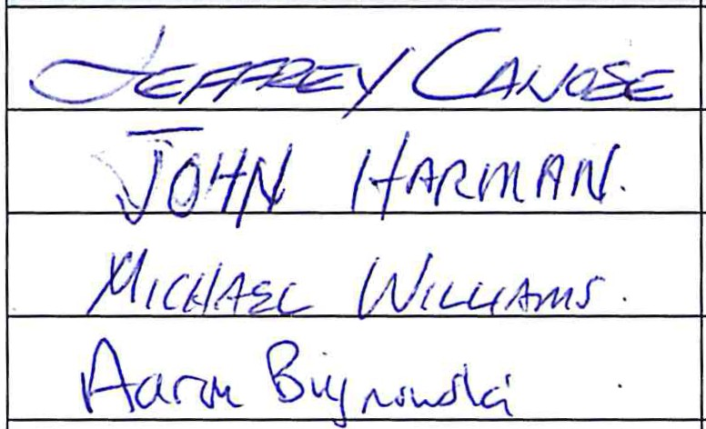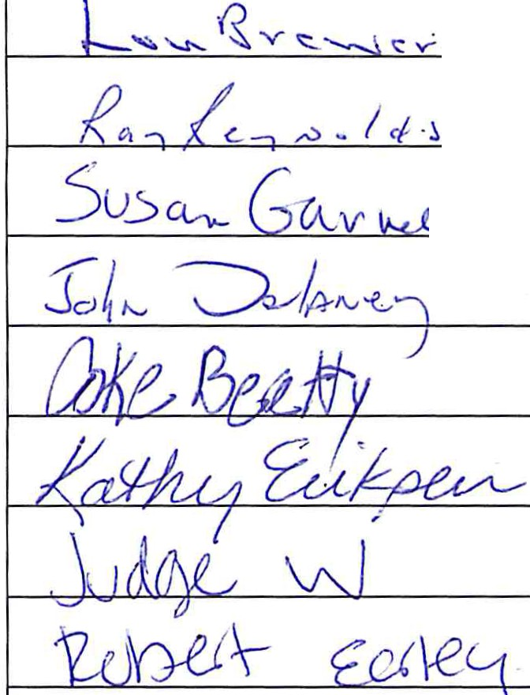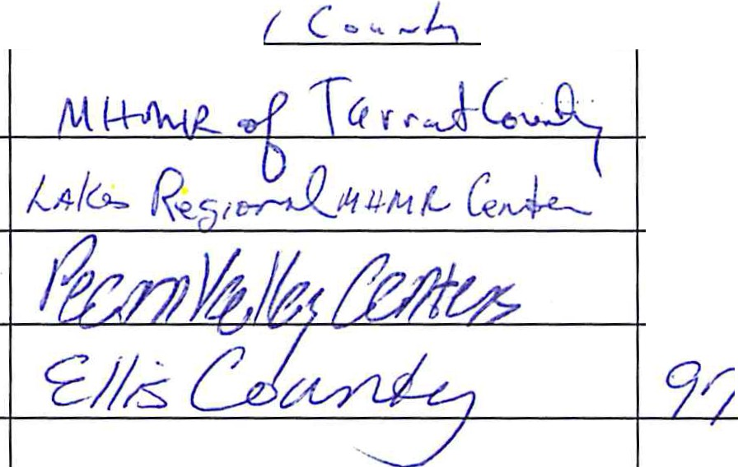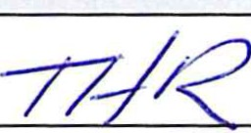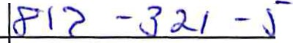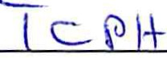Elected Official and Steering Committee Meeting

Name (Print)
Entity Phone

662- :?C/9.::7- I-7'.;' J

UIJrrfJL 2!7 -- 7Jf' }\23

/( 8'11-- 7-3{ - }.5(} 1

'\ (o.PL--ZJl!> - 7\ (o
E-mail

.S: ,:;, ..,-.. .- v..._t - C-tf Y'76 I , :>. ,'I, c; 7 1 Y<--r

9\ ll s-l 3>50

C)'?d- - 5/Jk- "!)J 7 3
C-tl? -j-7!J- il!fl/l

J>5553P
e -, -' c. I cl J e 'i •'"""' r. <: /" •.

{\{_ n V' ·fz ' O"rc,

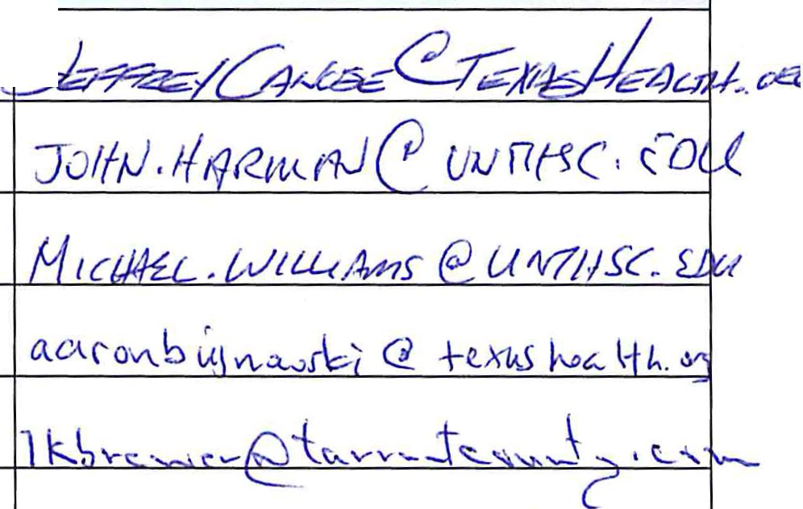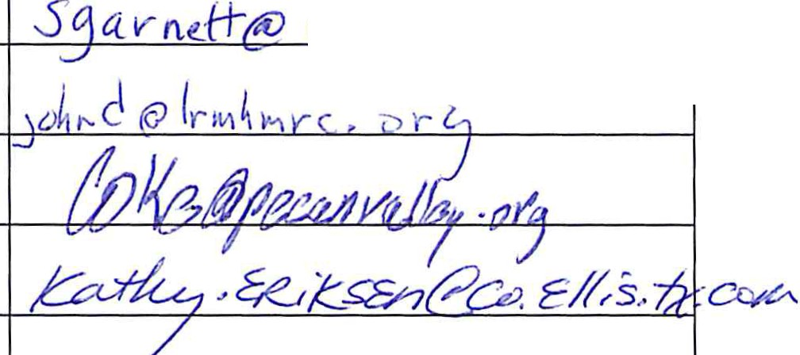

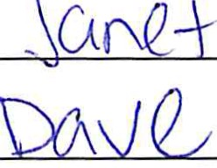0

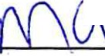------------. -----
"l A \\cY}

Today 's Agenda

REGION 10

JO INT MEETING OF ELECTED OFFICIALS AND STEERING COMMITIEES

June 24, 2013

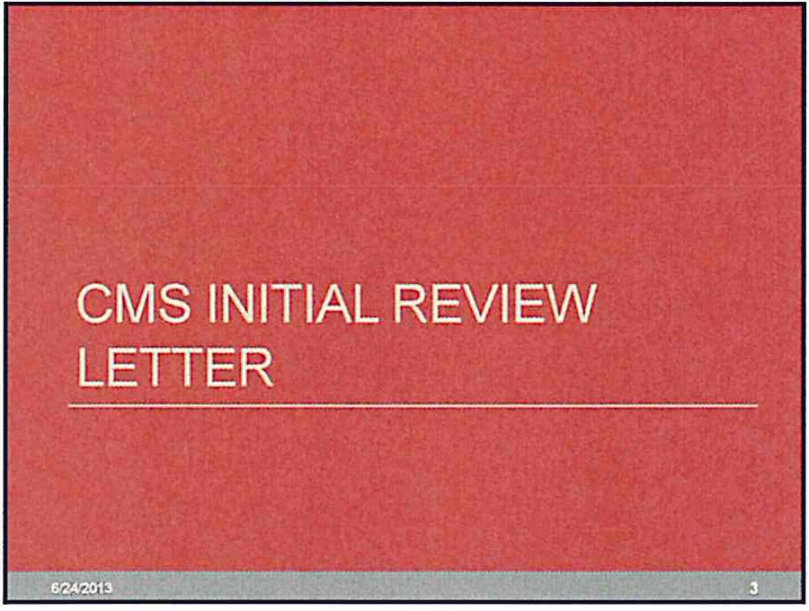

CMS Overview- Additional Feedback Related
to DSRIP Projects

  - Welcome/Meeting Coordination
  - Overview of CMS "lf!itial Approval " Letter
  - Four-Phase Revision Process to get to " Full Approval "
  - DY2 Milestone Reporting
  - Payment Update
    - DSRIP DY 1 Payment and Recoupment
- DSRIP Payment Cycle- DY 2 to DY 5
- 2012 UC Final Payment
- 2013 UC Proxy Payments
  - DY3 Plan Modifications & Addition of New Projects
  - Regional Engagement , Timelines and Next Steps
  - Region 10 Website Development & Symposium

CMS Overview- Feedback Related to DSRIP
Projects

- No.1 - Initially approved projects (Table 3)
  - No.2- Initially approved projects with priority technical
corrections (Table 4)
- No.3 - Projects initially approved , with an adjustment to project value (Table 5)
- No.4 - Projects not approved at this time (Table 6)
- No.5- Category 3 projects not approved at this time (Table 7)

- No.6- Category 4 Domains
- No.7 - Replacement Projects
- No.8- DY 4 and 5 values deferred
- No.9- Learning Collaborative Plans
. No.10- Post Award Forums

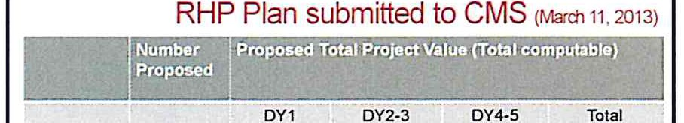Initial plan nla 548.707.230 $48,707,230
submission

r Category 1 111 s4o3.154.831 $411,909,038 $815,063,869
&2 (Projects)

Category 3 220 545.538.999 5116 .651 ,376 $162,190,375
(OUtcomes)

Category 4 18 521.985,585 534.402.375 $56,387,959
(ProvKiers)

Total 349 $470,679,415 $562,962,789 $1,082,349.434

By the Numbers CMS initially approved 84% of the projects & 79% of the DY1-3 $$'s requested

Initial plan n/a 548,707.230 $48,707,230
submission 100% 100%
Category 1 99 5306 ,010,154 Not $306,010,154
&2 (Projects) 90% 76% approved 38%
category 3 174 535,303,437 Not $35,303,437
(Outcomes) 79% 78% approved 22%
Category 4 18 521,985.585 Not $21,985,585
(Providers) 100% 100% approved 39%
Total 292 $48,707,230 $363,299,176 Approval $412,006,406
84% 100% n% deferred 38%
79% (DY1..J) to 9/1/13

Phases 1 - 4

PteiOcu llyaPPJQVod,wrtha.1ad ttof)l'ojoctv.llue '
(Tablo5)

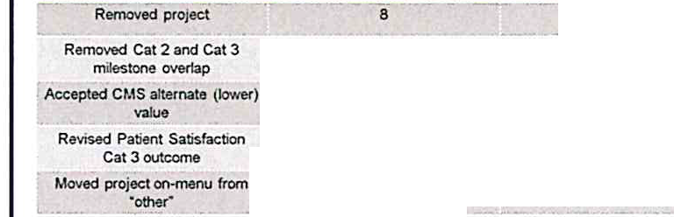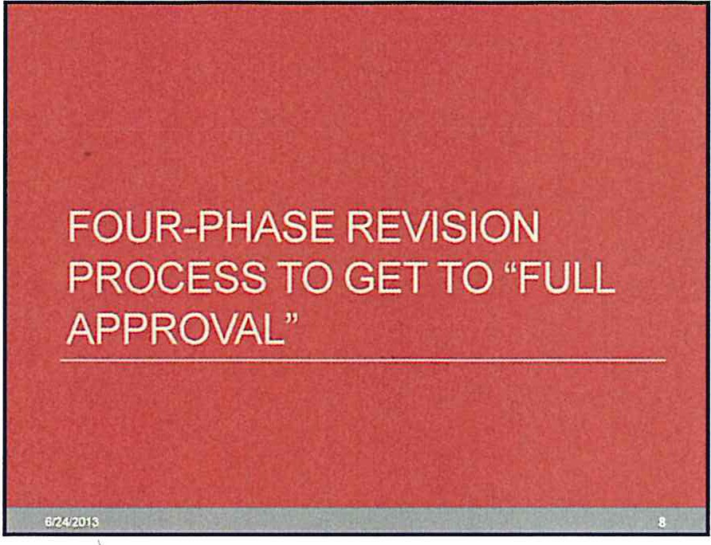

Phases 1 Submission

- 45 (of 111) Category 1 or 2 projects were modified in Phase 1

1 lmprowmant mi tonas overt.Jp imptovement br
(pfofocts.wilhpriclritfledlnic..llconlldionidontifiedinbbloo4 )

All ptojoets -COI'Ifin'rl.roviso, id.eo:dyq p; tivnt
2
ir!lp: ct and Modbld/ indigotll impa-ct 101' h profeet
Rogion t o :wb-Tlit:ed an Ph.2s. 1
rmslon$lo HHSCbyJurMJ 7,2013

TBDCb!eJunotoo:srtyJuly)
Providers affected

UNTHSC .J
Revision type |  | Number of Projects

THR Soutl'rNest THR H·E-8.
MEithodistMansfield
TCPH, MHMRTC.JPS.
UNTHSC
Plaza, Pecan Valley

AJlp.ojoctso!igiblo forAugustmilo!.tona pOOing
3 (T:tbloH3,4• .m:15ol CMSinlti.:ll RDView lllttaf)
4 Allproteds-prioritytechnic.11c.orr 'andCa:fi9QI'Y3
"""""
Regioo10:wbmii!Od:t A PNw3
r toHHSConJuno18 .2013

Od 1.2013

Revised project/ milestones to
retain proposed v.We

TCPH. MHMRTC

17 TCPH,MHMRTC.THRFW,
JPS, Wrse,THR AM,Baylor,
UNTHSC,JPSPG.WrsePG

Phases 1 Submission

- Known financial impact of Phase 1:
  - 8 Projects removed:
· Si9,395. 181(0Y2-5)
  - 8 Projects accepting alternate (lower) value :
• 519.214 .825 r educed (OY2-3)
- Financial impact of projects attempting to recoup value is
not quantifiable
  - Some projects alternate value was TBD due to lack of quantifiabl e
patient information available
  - Some projects alternate value stated, but will not know if HHSC/ CMS accept revisions and awa rd proposed va lue until later this summer

m

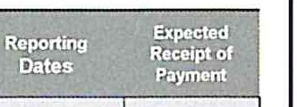DY2 Milestone Reporting Process and Timeline

- Manual process completed on an individual provider basis
- Only projects initially approved and those that accepted CMS alternate value are eligible to report in A ugust
  - A ll other project s , once approved, will report in October
- Providers will report by 8/ 30/ 13 on progress of projects through an excel template and uploading documentation to an HHSC SharePoint site
Estimated DSRIP Payment Calendar

OY1 (9130112) HHSC Plan Approval - Submission to 3111113 Poid
CMS - Refunded Amounts 7

1 Milestone Reporting thrOUGh 8!3 1113 813 1113 est November 13
DY2 (9130113)
Milestone Reporting through 9-30- 13 est October 13 est Febrwry 14
& Cati!gef)' 4ability to report

Milestone Reporting ttvough 3-3 1

  - HHSC will then review by 10/ 1113 providers repo rts and determine eligible
OY3-5 and annual Category 4 Reporting
4130 est. June

payment amounts
- IGT will be due mid-late October for Aug ust reporting with payments
Milestone Reporting tnrough9130 Hl/31 est. January

Category 3 outcome metric.s

processed in mid- November
- HHSC will provide a process/timeline for October DY 2 reporting in July.

DY4-5
reporting through 3-31

Category 3 outcome metrics reponing tlvough9-3-
4130 est June

10131 est. January

1115 Waiver Payment Update

- DSRIP
  - 1% rule for funding HHSC audit and administrative requirements
  - UC payments
    - FY 2012 UC
      - "Haircur required due to over subscribed available IGT
      - Final Payment Made and Reconciled
    - DSH Payment Impact/Catch-up Payments
    - FY 2013 UC
- Statewide cap increased from $3.78 to $3.98
- New IGrs- Senate Bill 1623 allow s for a provider tax for TX/MEX border counties and other {i.e., Travis County increased property tax)
- SFY 2013 UC tool
- Proxy Payments for SFY 2013 Q1, Q2 and Q3 interim UC payment outstanding
Who will qualify for a DY2 UC advance or
"Proxy" payments?

1. The provider must have a source of public funding for the non·federal
share of the advance payment.
2 9 0
. S e rio r 1u?lti n Yfh c n Y ; eq i edw ith
affiliation agreeme nt and the signed certificatio ns for t he provrder and the gove rnment entity.
- The provider must be listed in its Regional Healthcare Partnership's
(RHP) plan as a participant in the RHP.
- The provider must have been actively enrolled as a Medicaid provider
in the State ofTexa s at the beginning of DY2 (Octobe r 1, 2012).
5. The provider must have submitted, and be eligible to receiv e payment for, a Medicaid inpatient or outpatient claim for payment during DY2.
6. The provide r must have either submitted an accept able UC application (UC tool) for DY1 or have been eligible to receiv e a transition payment for DY 1, regardless if a UC payment was received or not receiv ed for DY 1.

Important Dates

·May - Sept. 2013 Phases 1- 4 RHP Plan revisions take place July 31, 2013 Replacement projects due tq HHSC
August 30, 2013 DY2 milestone progress reporting
September 1, 2013 CMS Completes first valuation review for DY4-5
incent ives
October 1, 2013 -Priority technical corrections submitted to HHSC
- CMS and HHSC complete standard target setting methodology for Category 3 outcomes
RHPs submit learning collaborative plans

March 31, 2014
Deadline for full project approval Technical corrections
Modifications to projects or valuations
Category 3 improvement targets for DY4-5

- Public Engagement
Other Items for Discussion
Other Items for Discussion

- Revised Region 10 Website :

  - Commissioners Courts Date and Times
·Learning Collaboratives
- Moving from Concept to a Formalized Plan
  - Quality/Clinical Committee Role and Collaboration Focus
·Unused DSRIP $'s/DY 3 New OS RIP Projects
·Other
·Manager, Region 10 RHP- Mallory Johnson
  - Revised Program Funding and Mechanics Protocol (April 4, 2013 available online)
    - Continually updated w ith new informa tion, deadlines, and documents
·www.RHP 10TxWaiver.com

·Waiver Symposium
·" Unlock the Mystery of the 1115 Wa iver"
  - September 23 & 24 Sheraton Fort Worth Hotel
  - More information available online

Appendix E:
August 8, 2013 RHP & Public \vebinar / conference call regarding the process for 3-year projects

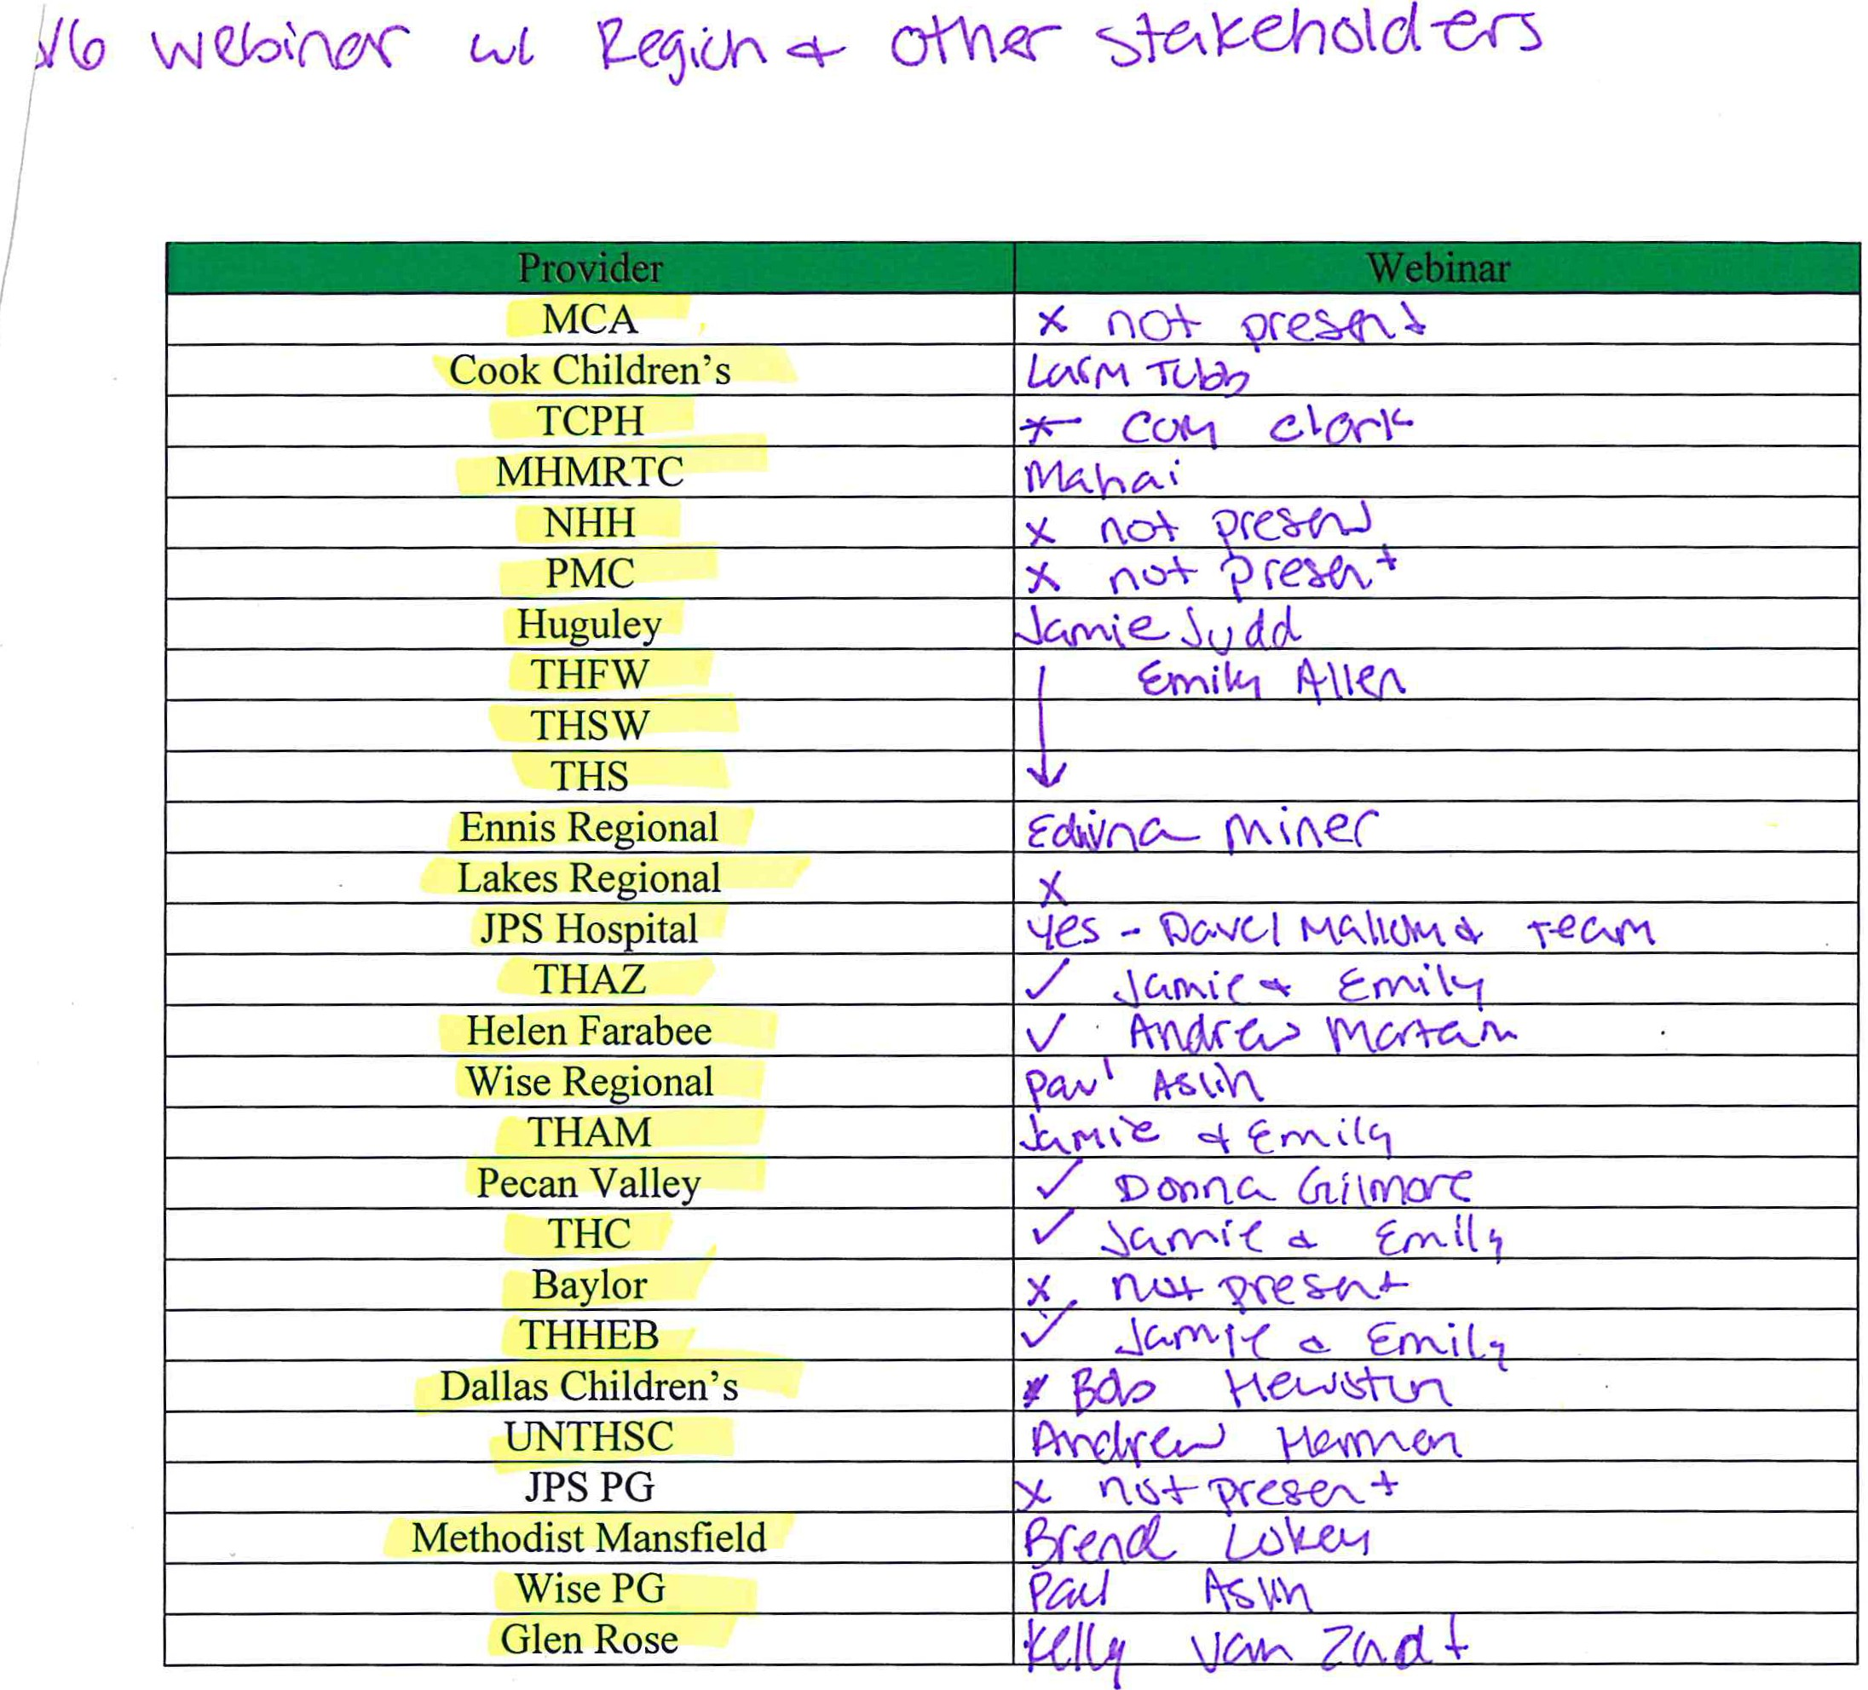I
I
I

UC Only

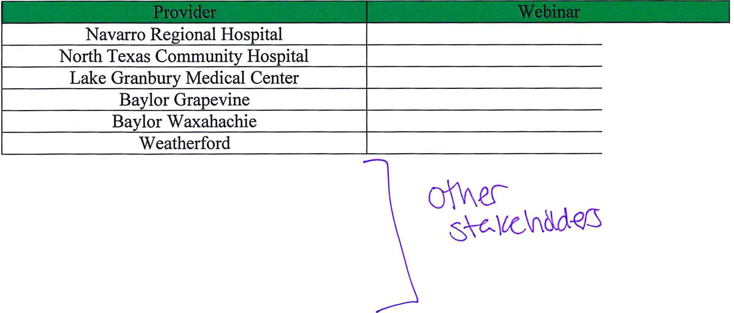rYIWtt '\)f\f{:r- A-dYCU\CcJ.. H1-Jq CoVL
W!JG- 'Stcr [,A j H.cc._ l1kC5H"G

a,v\a - (Y\01\C<\<'-t

REGION 10

REVIEW OF PROPOSED PROCESS FOR ADDING 3-YEAR DSRIP PROJECTS

August 6, 2013

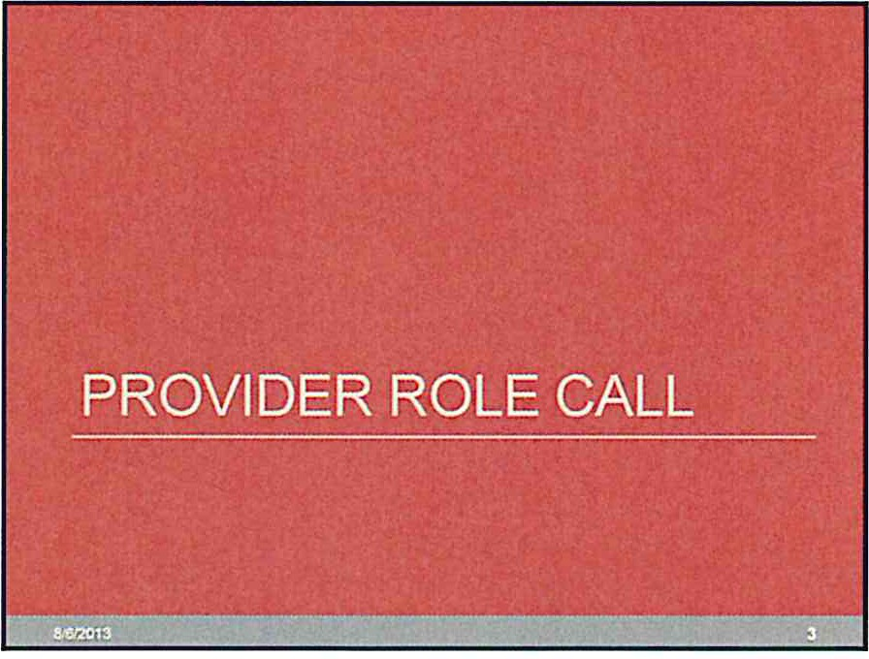

Background - 3 Year OSRIP Projects
  - What is the 3-year DSRIP Project?
    - The addition of new projects in OY3 to the RHP Plan financed by new or exist ing
IGT entities and implemented by an existing and/ or new Preforming Prov ider.
.,..,ith broad participation encouraged buy HHSC and CMS
    - These projects shall be 3 years in duration , beginning in Demonstrat ion Year (OY) 3 and should be operational with in a 12 months

·What DSRIP allocation is available for 3-year projects in Region 10?
· Two so urces:
      - Minimum unallocated Region 10 dollars:
        - S 109,324,057 unused DSRIP dollars and canceled proj ects
      - Unknown dolla rs:
        - Re maining dollars fro m final project reduced valuatio ns in the Region
- Unused dolla rs from other regions
- DSRIP allocatio n taken in by HHSC for statewide pr ojects
Today 's Agenda

·Provider Role Call
·Background of 3-year OSRIP projects
- HHSC Rule
  - Project Requirements
  - RHP 1 Evaluation Process
·Timeline
·Questions
·Other Information and Follow Up Items

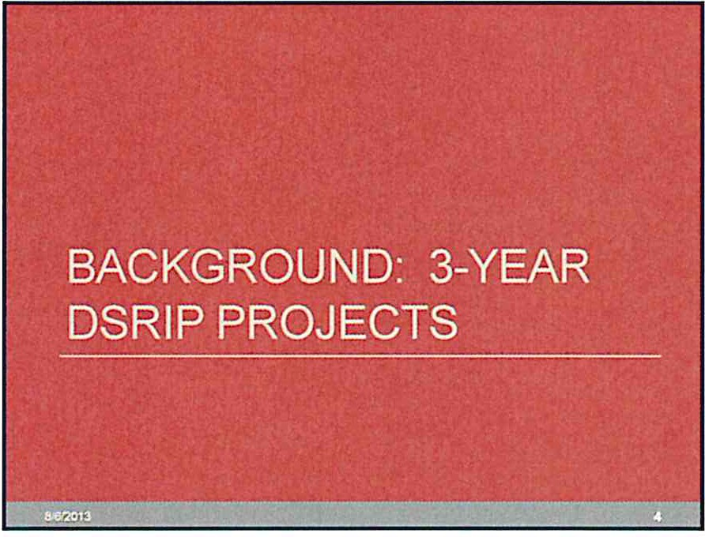

Background - 3 Year OSRIP Projects
  - How does this relate to what we have learned about DSRIP projects?
- Similarities to w hat we know about current DSRIP projects:
  - Same plan template will be used to write project narratives
- Projects will include milestones I metrics
- Projects will be selected from a state and CMS approved menu
- A public hearing and feedback opportunity will be available for proposed projects
    - Differences from what we know today about DSRIP projects:
      - A formal process to call for projects is required
      - A forma l evaluation and ranking process for project selection is required
- HHSC will define and initiate statewide project s
- There will be more focus on Category 3 outcomes selected and
overa ll impact and less emphasis on milestones
- Update project menu available

·t'Zm

Funding
- IGT availability is the scarce resource
·Allocation of available $$$
- Dependent on Regiona l Project Requests
  - HHSC has not been definit ive on methodo logy
- Default position is PFM requirements- similar to Pass 3 approach
·Where does that leave us?
- Avai lability of JPS IGT is dependent on JPS desire for additional projects
and necessity to meet the 30% rule
- Gauge regional interest in addit ional 3-year projects
- HHSC rule requires project list submitted to HHSC alternated by IGT provider prior to complete OSRIP write-up and completion

Outline of the HHSC 3Year OSRIP Project Rule
  - Background
·Administrative Rule Making
  - RHP Plan Modification Requirements
·Project Prioritization Within Each RHP
- HHSC Promotion of Region 1 Evaluation Tool
·Formal Project Submission and Review
- Mid October- Submit to HHSC
- December 31. 2013 - HHSC Rev iew Complete
    - March 1, 2014 - CMS Appro v al

·009

New/Modified Requirements for 3-year DSRIP Projects
- Represent an intervention that is in response to community needs identified in the RHP's needs assessment specific to Medicaid and Indigent populations
- Be on the RHP Planning Protocol DSRIP menu and not an 'other'
project option and also not include 'other' Category 3 outcome(s)
- Include QPI milestones in DY4 and 5 that include Medicaid/Indigent
quantifiable impact
- Submitted along with a completed OS RIP Electronic Workbook
- Projects not allowed as options for 3-year projects:
  - 2.4 R edesign for Pat ient Experience
- 2 .5 Redesign for Cost Contn inmcnt
- 2 .8 Ap ply Process Improvement Methodology to Improve Quality/ Effic iency
- 1.10 Enhance Perfonnancc Improvement Reporting Capacity-) <llowablc only for projects th:1t focus on OSR IP lea rning collaborattives
- Projects under 1.9 Specialty Care Capacity must include a minimum focus of 40% Medicaid and Indigent, unless a compelling justification can be made for a lower threshold

·!1Z'm m

HHSC Rule (see attached)

  - New rule from HHSC will be adopted by September 1, 2013
  - Plan modification process begins once all RHP plans receive initial CMS approval allowing RHPs and the State to use unclaimed RHP allocations
  - Each RHP must submit a list of all 3-year DSRIP projects considered
    - A formal prioritization of proposed projects within each RHP must occur
      - The State is advocating for a process similar to RHP 1 be used
      - Prioritizatio n will be based, among other items, on regional needs and will be- listed by
alternating affiliated lGT entities
    - Formal project submission and rev iew will occur at a later date
      - Projects will be submitted to HHSC by mid-October
- By t2J31/ t 3 HHSC \•iill complete review of full project proposals
- By 311/ 14 CMS a pproval of new 3-year projects \'iilltake place

·!21ml

Requirements for 3-year DSRIP Projec ts
- Include milestones that represent implementation activities beginning in OY3, not just planning activities

- Certain milestones may be edited, added to,or removed from the RHP Planning Protocol. HHSC will propose these updates to CMS in order forthe revised RHP Planning Protocol to be finalized no later than September 1, 2013.

.n:;m

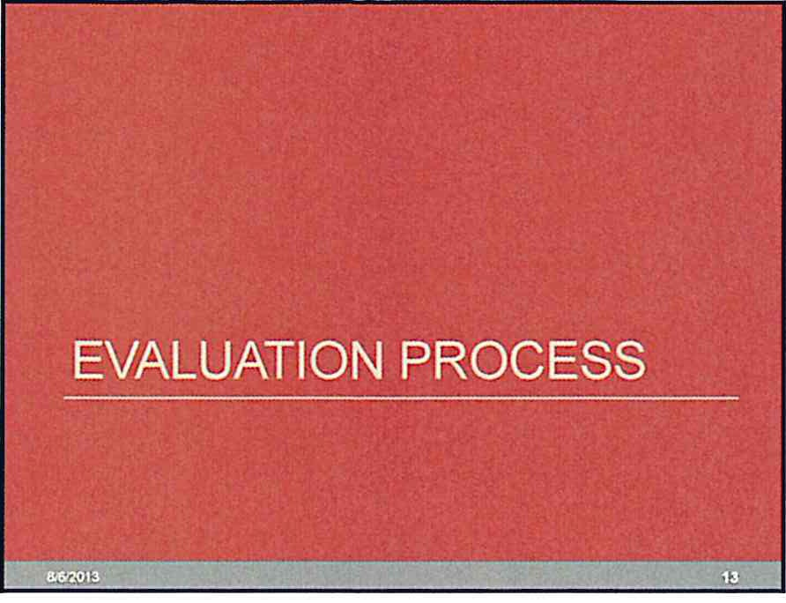

Evaluation Process
- RHP 1 used a weighted Likert scale approach to evaluate proposed
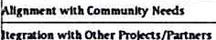projects on five criteria domains

Evaluation Process
- RHP 10 is considering using a similar process to RHP 1 in order to evaluate and prioritize proposed new 3-year OS RIP projects
- Projects will be evaluated among a number of criteria which may
include
  - A lignment with community needs
- Transformationa l I mpact
- Integration with other proj ects/ partne rs
- Known IGT source
- Impact on Medicaid/ Indigent populations
·Please provide feedback for Region 10 process by August 16, 2013

Evaluation Process
- RHP 10 is requesting a formai"Call for Projects" in order to
understand the level of provider interest in new 3-year DSRIP projects

,_,.,._......, .."""
..

f....Rnw-nDdudJootScorioo&n-:ripfon
 | '0/fln o btnlm•raiRnH |  | NUI>MIIutlhr iii' O H..,/rJo  c:-s-...51  v 0111'011 ...11. 011 ·•--a aon­  I'll -- "..... .....abot .....
 | s....
 |  | ..... | Slroa but _llo ..,_..,..,.,,_wralawton.
 |  | "'"....... | S.... sun lo• N-II IIIIItau .... .., wnbon o.  Alrwlln • lltaadallrw wrabw1on.  v '"""•ll• ....t ...-·................

...
  - Complete a review of RHP 1 cv< luation process :md provide feedback
  - Complete RHP 10 Call for Projects Tcmplntc and rctllrn
!) Project Option
2) Brief Project Description
J) IGT Entity (if known)
4) Community Need(s)Addressed
- Project goals
G) Anticipated Medicaid/Indigent Population Impact
  - Estimate or Numbers (encounters or Individuals)

Ex!...- aro - • lirwr_..>«.
  - Percent or toUI population or project served
?) Category 3 Outcome(s) Selected
- lmpact on other projects
  - ) B)" pf O I Idtr
11 \VMinRHPIO
9) 0perational within 12 months (yes/no)

Timeline
- By mid·September 2013 by a date specific by HHSC, each RHP must submit a
prioritized list of possible new J.year OSRIP projects (tentative)

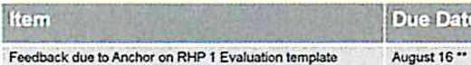
.Atlehot to prcMdo RHP 10 E IJ.ltion Tcmpbto to p!'<Mders Augvs.t 23
PnMdors $Ubmft Ia And..or 'Co:IH for Pr ts· Tampbto August 30 "
Ccmplo!o reviGw ot ptoj«tpr :lnd priofftizot;...t Seplcmbot 9
OlCCO!d mg 10 HHSC r oquir ments
f'ublie holdtorcMGwpriontiz'Cldri-..fcf3-YoatPfofoet$ Seplernbt:r t3.2013 Submi'tlb!ol prioritizcd proj«IS to HHSC Estim: !l:d Scptetnbor 16.2013 Prwiden complete run ptqoets proposod ;u/'ICW 3- o31 I.0eto01:t 2013 (TBO) ••
ptOfotts mdAnd!Of:.ubmltto HHSC

CMS roviawd\ blo-:lpproye d prt;octs atlclcontirm .,pprovaJ ByloUr eh 1.20tot ,prioflothe M.t0Y3 r eporting opportunity
inApril2014

TexasA&M Evaluation SuNey
  - Texas A&M has been hired by HHSC to preform an evaluation of the Waiver in Texas per CMS requirements
  - Texas A&M is looking for contacts within the Region to complet e two
surveys
- To determine the right contact for each survey they are looking for:
  - Int er-organizational Network Survey: An organizational representa tive that is know ledgea ble about the organization 's relationships with othe r organizat ions in the region. such a s collaboration for training and services or forma l dat a sharing. (UC-only hospitals will not be contacted fo r this survey.)

  - RHP Member Surv ey: An organizational representative that was active on behalf of the organization in the wa iver planning process and is knowledgeab le about
the organization's waiver activities.

    - Complete the cont act request form distributed with the appropriate contacts for each survey for your organization and return to Anchor by Friday August 16, 20 13

EIJ

Follow Up Items
- Read HHSC rule regarding 3-year DSRIP projects
- Provide Feedback to Anchor on RHP 1 Evaluation Process
· Augu !>t 16, 201 3
- Complete Texas A&M Evaluation Contact Survey & submit to Anchor
· A u gu !>l 16, 2 013
- Complete Call for Projects Template and submit to Anchor
· Aug u !>t 30, 2013

- Other Regional Updates :
  - Phase 1 Projects and new 15-day cloc k f o r C MS R ev iew
    - CMS will in 15d; y dock for .; 11 Ph'n 1 pro etsonce .1111 RHP 10 proje-etshave be<en re-eeived
    - CMS turrenUyhn46 "!. ol RHP 10Ph; e 1 Proje-e!s
  - DY2 Repo rting Template
    - Should tH: ; v.llibble soon lor August reporting
  - Le< ming Collabo rativ e Template
    - HHSC published .11 templ31<.' f or region\ to r esubmit LC pl; ns -if you h; ve le-edb.:lck ple.115eprovide to HHSC
  - UC Payments s hould hav e been received 8/ 512 0 13

·121m

